Year 1
Who are we and where are we?
The UK
Links made with other subjects | British Values  English - ‘Katie in….. ‘ / ‘The Knight who took all Day’  History - Castles
The BIG Question | Who are we and where are we?
The BIG Outcome | Children demonstrate the knowledge they have learnt during this unit by drawing / completing their own sketch map of the UK and populating it with capital cities, landmarks etc.  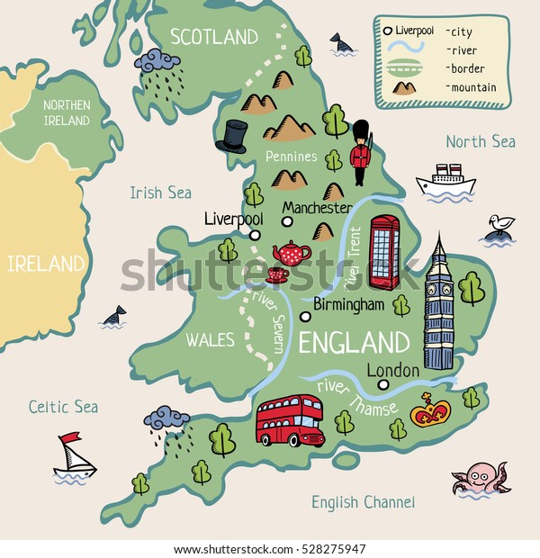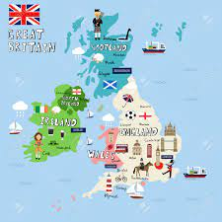
Geography objectives  (link to NC) | - Name, locate and identify characteristics of the four countries and capital cities of the UK and its surrounding seas.  - Use world maps, atlases and globes to identify the UK and its countries.  - Use simple compass directions to describe the location of features on a map and locational and directional language e.g. near, far etc.  - Use aerial photographs to recognise landmarks and basic human and physical features.
Prior knowledge  What prior knowledge is needed for children to be successful in this unit? | Children already know:  Reception – Know about the world around them.
Future learning  Consider the conceptual knowledge within a subject that pupils need for future learning not just the recall of facts but the importance of concepts | This unit gives prior knowledge to:  Y1 – Town Mouse, Country mouse (and seaside Mouse too!) Comparison between Bradford, Filey and Skipton  Y2 – Where in the world are we Continents and oceans.  Y2 – Where would you rather be? Comparison between UK and Kenya  Y4 – The Journey to the Sea. Rivers.
Geographical strands | Geographical Skills  - Use world maps to label and annotate the UK and UK seas.  - Use the compass directions to describe the location of features on a map.  Locational Knowledge  - Know the UK countries  - Know the UK seas  - Know key UK cities  - Know key UK landmarks  Place Knowledge  - Know key UK rivers  Environmental, human and physical geography  - Know key characteristics of each country (flags, emblems, foods)
Vocabulary/ Glossary | country, city, river, capital city
Knowledge  (see italics for knowledge to remember) | The knowledge that children will learn and remember:  - The four countries in the UK are: England, Scotland, Wales and Northern Ireland.  - The Seas that surround the UK are: North Sea, Irish Sea, Atlantic Ocean and the English Channel  - The capital cities are:  England: London  Scotland: Edinburgh  Wales: Cardiff  Northern Ireland: Belfast  - The Thames River flows through London. The River Aire flows through Northern England.  - Key landmarks:  England: Buckingham Palace  Houses of Parliament + Big Ben  Stonehenge  Humber Bridge  Scotland: Edinburgh Castle  Hadrian’s Wall  Loch Ness  Ben Nevis  Wales: Mount Snowdon  Menai Bridge  Caenarfon castle  Northern Ireland: Giant’s Causeway  Titanic (Belfast)  Key Characteristics:  National Emblems: England – Rose  Scotland – Thistle  Wales – Daffodil  Northern Ireland – Shamrock  National Flags:  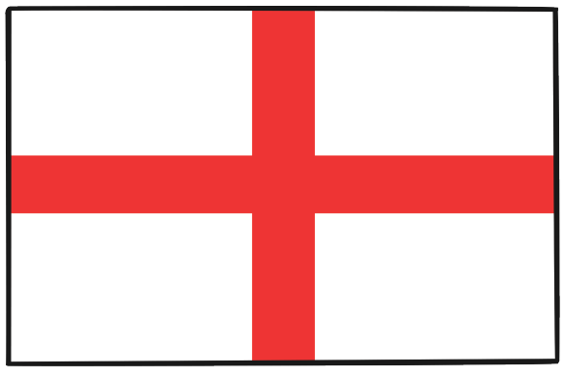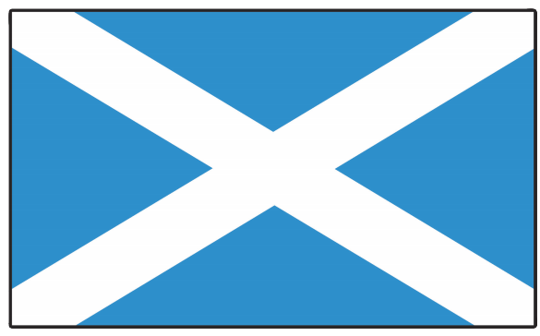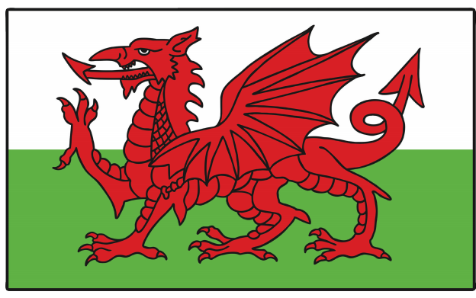  England Scotland Wales Northern Ireland  Patron Saints: England – St George  Scotland –St Andrew  Wales – St David  Northern Ireland – St Patrick  National Dishes: England – fish and chips, Cornish pasty, Yorkshire pudding, cream tea  Scotland – haggis, cranachan, clootie  Wales – bara brith, leeks  Northern Ireland – soda bread, champ, potatoes  - The 4 points of a compass are: North, East, South, West (Naughty, Elephants, Squirt, Water/ Never, Eat, Shredded, Wheat) / locational language e.g. near, far.
SEND expectations | - The four countries in the UK are: England, Scotland, Wales and Northern Ireland.  - The Seas that surround the UK are: North Sea, Irish Sea, Atlantic Ocean and the English Channel  - The capital cities are:  England: London  Scotland: Edinburgh  Wales: Cardiff  Northern Ireland: Belfast  - The Thames River flows through London. The River Aire flows through Northern England.  - Key landmarks:  England: Buckingham Palace  Stonehenge  Scotland: Edinburgh Castle  Wales: Mount Snowdon  Northern Ireland: Giant’s Causeway  - Key Characteristics:  National Flags:  England Scotland Wales Northern Ireland
Suggested Teaching Sequence  Exploring the 4 countries one at a time allows for a more immersive experience where the children can try some of the foods and ‘experience’ the country more. This would make it more memorable. | Session One  Points 1, 2 and 6. Understand what the UK is. Look on a map and find the key facts outlined. Use the points of a compass / locational language to describe where they are.  Session Two  Points 3 and 4. Understand what a capital city and river is. Know the capital cities for the UK and the River Thames. Plot on a map.  Session Three  Point 5 – England. Know key facts: landmarks, emblems, patrons saints, the flags and national dishes.  Session Four  Point 5 – Scotland. Know key facts: landmarks, emblems, patrons saints, the flags and national dishes.  Session Five  Point 5 – Welsh. Know key facts: landmarks, emblems, patrons saints, the flags and national dishes.  Session Six  Point 5 – Northern Ireland. Know key facts: landmarks, emblems, patrons saints, the flags and national dishes.  Session Seven – Assessment  Recap what the UK is and the 4 countries that make it up. Children create map of the UK. This would need to be a provided outline. Depending on ability, children could sort pictures or draw and animate themselves.

