**Art Vocabulary**

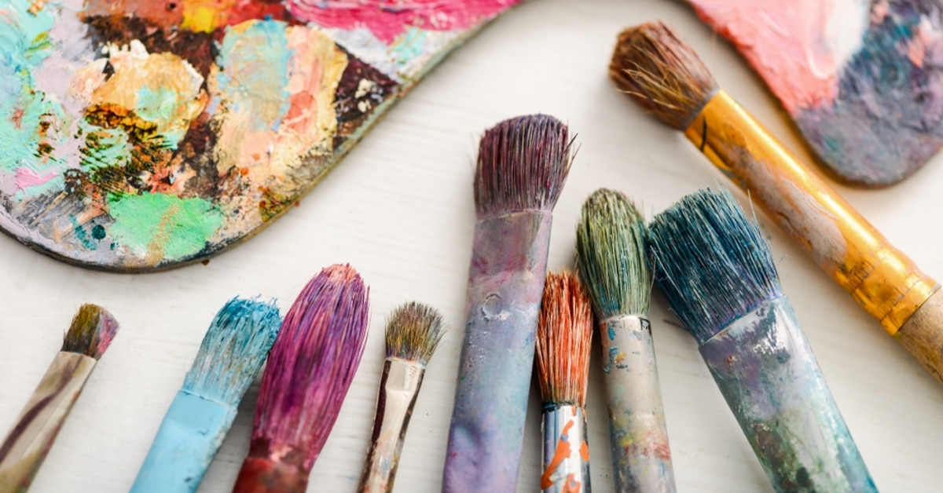

shade reflection shadow

direction of sunlight mood

**Art Vocabulary**



colour palette mood atmosphere perspective shadow reflection influence architecture design personal style Frida Kahlo

**Art Vocabulary**



visual tactile contrasting over print justify sculpt mould carve scale architecture stability form proportion abstract interpretation Salvador Dali