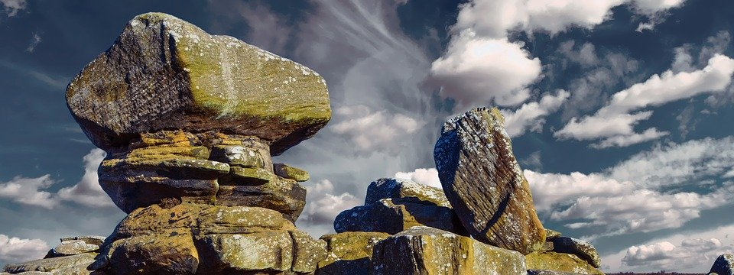

Any other words:

**Science Vocabulary**

**Rocks**

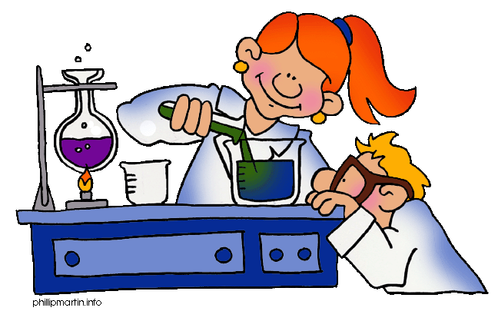

**Y3: Rocks and soils (rocks and soils)**

Rock, stone, pebble, boulder, grain, crystals, layers, hard, soft, texture, absorb water, soil, fossil, marble, chalk, granite, sandstone, slate, soil, peat, sandy/chalk/clay soil