To count up and down in tenths.
Recognise decimal equivalents of tenths.

By the end of this half term, children should know the following facts. The aim is for them to recall these facts instantly.
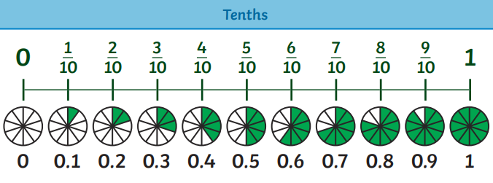 | Key vocabulary  Tenths  Decimal tenths  Numerator  Denominator  Unit fraction  Non-unit fraction  Equivalent
- They should be able to count up and down in tenths; recognise that tenths arise from dividing an object into 10 equal parts and in dividing one-digit numbers or quantities by 10

Top Tips
The secret to success is practising little and often. Use time wisely. Can you practise these KIRFs while walking to school or during a car journey? You don’t need to practise them all at once: perhaps you could have a fact of the day.
Use memory tricks – For those hard-to-remember facts, create picture stories to help children to remember.

Recognising Tenths Interactive Mad Maths: Answer as many questions as you can. Use the 'Enter' key or press 'Go' to submit each answer. Your time starts after you answer the first one.

http://www.snappymaths.com/counting/fractions/interactive/tenthsint/tenthsint.htm

Help Boop and Hop use their knowledge of fractions to create pizzas in the Year 3 Tenths Interactive animation. What is your favourite pizza topping?

https://kids.classroomsecrets.co.uk/resource/year-3-tenths-interactive-animation/

