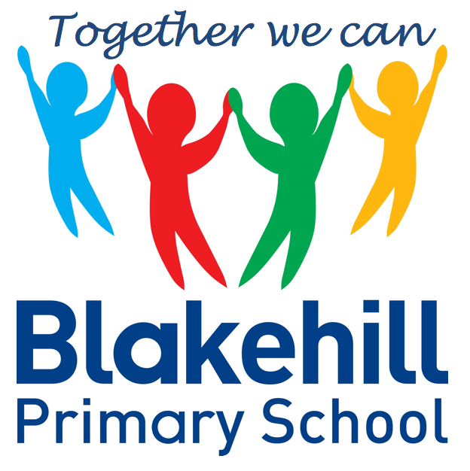
Personal, Social & Emotional
Children will be taking part in weekly circle times. They will have the opportunity to talk about themselves and their family. Children will be encouraged to take turns and listen to each other. We will also be talking about our wider school family. Children will also be learning more about how to look after their teeth.

Reading & Writing
Children will move on from bringing home a story book to share with you to a phonics based book. Please ensure your child keeps their reading record in their book bag and practises reading any sets of words sent home as often as possible. Please share a book with your child as often as possible, every day if you are able. In writing children will be practising name writing daily and learning the correct formation for each letter. You can help at home by using the wipe clean handwriting board sent home and helping your child to form and size the letters correctly by starting at the dot. Your child’s name should start with a capital letter, but the rest of the letters should be lower case.

Our focus for this half-term will be Traditional Tales, which will be the stimulus for much of our cross-curricular work. We will also be covering work on Black History and looking at Remembrance and Bonfire Safety. We will look at changes in seasons and features of our immediate environment and do a fieldwork study on our school grounds. In the build up to Christmas we will be finding out about the Christmas Story and practising our Nativity.

Understanding
the World
We begin every morning with ‘Go Noodle’ to get active and every afternoon with ‘Dough Disco’ to work on our fine motor skills. This will help to prepare us for writing and develop pencil grip and control. There will be daily opportunities ( weather permitting )for children to play outside during this half term.. Every Friday children will do PE with Mr Simmons, our PE coach.

Putting on our jumpers/coats independently

During this half term we will begin focused phonics teaching every day. The first set of graphemes we will learn are, s,a,t,p,i,n, m and d. When the children know these sounds they will start to blend them to make words. We will arrange a Phonics Workshop for parents, with advice on how you can support your child at home.
Children will have the chance to work creatively every day. There will be weekly music sessions with Mrs Brown. This half term children will be singing familiar songs and nursery rhymes. They will be exploring sounds and will have the opportunity to use different musical instruments.

Book Bags- Please remember that your child needs to bring their book bag to school every day.
Water bottles- Please make sure that your child has a clearly named water bottle in school every day. Please don’t transport your water bottle in your book bag as the water can damage the reading books if they leak. Please also make sure that the bottle contains only water and not juice.
PE kit- Your child only needs an indoor PE kit in school at the present time. This should be navy shorts, white t-shirt and black pumps.

Other information
Half Term Curriculum Overview

We will be doing a maths session after lunch daily. Our topics for this half-term will be:

It’s Me 1 2 3! - Representing 1 2 3 / Comparing 1 2 3 / Composition of 1 2 3 / Circles and Triangles / Spatial Awareness

Light and Dark - Four / Five / One more and one less / Shapes with four sides /
Night and day

You can help at home by supporting your child in understanding the three rules of counting :
- Count everything once.
- Say the numbers in the right order.
- The last number you say is how many in the set.

Mathematics
Physical Development
Phonics
Expressive Art & Design

Reception Autumn 2 Term 2021
Traditional Tales

