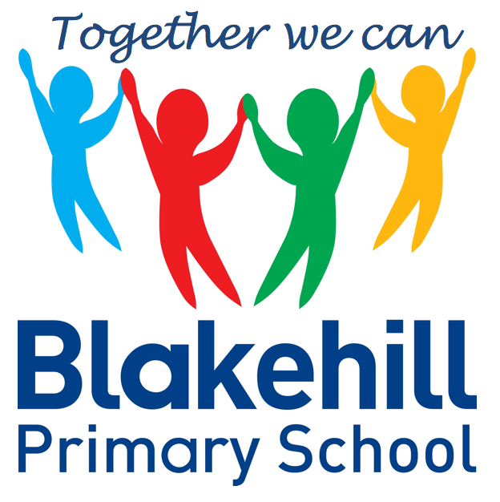
English
Our work this half term will be based around animal habitats. We will be writing about animals and the places in which they live. The children will be reading a book called ‘Leaf’ by Sandra Dieckmann, which highlights the plight of polar bears in today’s changing climate. The children will be writing their own stories based around the book.
- Geography The children will be exploring weather patterns in the UK and comparing the weather with a non – European locality.
- Art Collage and sculpture. The children will be making clay models of animals in their habitats. They will also be doing some observational drawing of fruits and vegetables.
- Science Feeding and Exercise. We will learn about the importance of exercise, hygiene and eating the right amounts of different types of food. The children will also be learning about ‘Food Chains’
- DT Cooking and Nutrition. The children will be learning about where food comes from and will be designing and making a healthy snack.

Science, History, Geography, Art and D&T
- PSHCE Making choices about health and well-being. Know that exercise is healthy and learn about diseases and how they spread.
- RE The children will be learning about some of the threats to the environment and some of the animals that are in danger. We will be talking about what can be done to help.

- Outdoor athletics
- Games
Outdoor PE is on Fridays. Indoor PE is on Mondays. Please ensure your child has their PE kits in school on these days, and that it is all clearly named.

- E safety- know that some of the people they interact with online may not be who they say they are.

- Maths: KIRFS will be given to the children and will be tested weekly (Tuesday)
- Spellings: Word Mountains will be tested on a weekly basis (Wednesday) Please ask your child to hand in their KIRF/ Word Mountain card on the days of the tests.
- Reading: Read with your child as often as possible. Books are changed when necessary.
- Please ensure every day that your child has a water bottle, filled with water only please.
- Any money sent into school should be in named envelope. Thank you.

Other information
- The children will be listening to and appreciating ‘Peter and the Wolf’ by Prokofiev. We will be using instruments to represent the animals.
Half Term Curriculum Overview

- Consolidation of work covered over the year.
- Measurement- time
- Movement and turns
- Mass
- Capacity
- Temperature
- Investigations
- Position and direction

Mathematics
PSHCE and RE
Physical Education
ICT
Music
Year 2 Summer 2 2021

