  Stage 3 KIRFs | Examples | KIRF Target | Achieved
I know all my Stage 1 & 2 KIRFs | Revise & ensure children have instant recall of facts from Stage 1 & 2 before moving on. |  | Date:
I know that 0.5 = ½ | 0.5 = 1 1.5 = 1 ½ 2 ½ = 2.5… |  | Date:
I can convert between cm and mm | E.g. 7cm = 70mm 90mm = 9cm 27cm = 270mm 37mm = 3.7cm |  | Date:
I know all of the 3 times table facts | All of 3x table facts 1x to 12x in random order |  | Date:
I know all of the 4 times table facts | All of 4x table facts 1x to 12x in random order |  | Date:
I know all of the 8 times table facts | All of 8x table facts 1x to 12x in random order |  | Date:
I know how to use known number facts to solve problems with bigger numbers | E.g. 4 x 2 = 8, so 4 x 20 = 80 12 ÷ 3 = 4, so 1200 ÷ 3 = 400  3 + 7 = 10, so 300 + 700 = 1000… |  | Date:
I know the inverse for all of the 3 times table facts | 3÷3=1 6÷3=2 9÷3=3 12÷3=4 15÷3=5 18÷3=6 21÷3=7 24÷3=8  27÷3=9 30÷3=10 33÷3=11 36÷3=12 |  | Date:
I know the inverse for all of the 4 times table facts | 4÷4=1 8÷4=2 12÷4=3 16÷4=4 20÷4=5 24÷4=6 28÷4=7  32÷4=8 36÷4=9 40÷4=10 44÷4=11 48÷4=12 |  | Date:
I know the inverse for all of the 8 times table facts | 8÷8=1 16÷8=2 24÷8=3 32÷8=4 40÷8=5 48÷8=6 56÷8=7  64÷8=8 72÷8=9 80÷8=10 88÷8=11 96÷8=12 |  | Date:



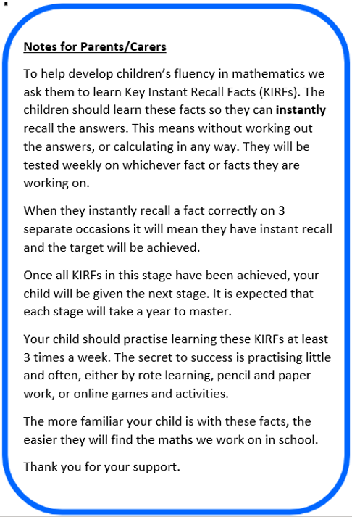
KIRFs
Key Instant Recall Facts
Stage 3

Name:_______________________________ Class______

Date Started:____________________

