To know number bonds to 20.
To know odd and even numbers to 20.
By the end of this half term, children should know the following facts. The aim is for them to recall these facts instantly.
Number Bonds to 20  What can this look like?  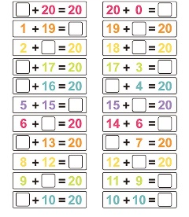  Concrete: Pictorial: Abstract:  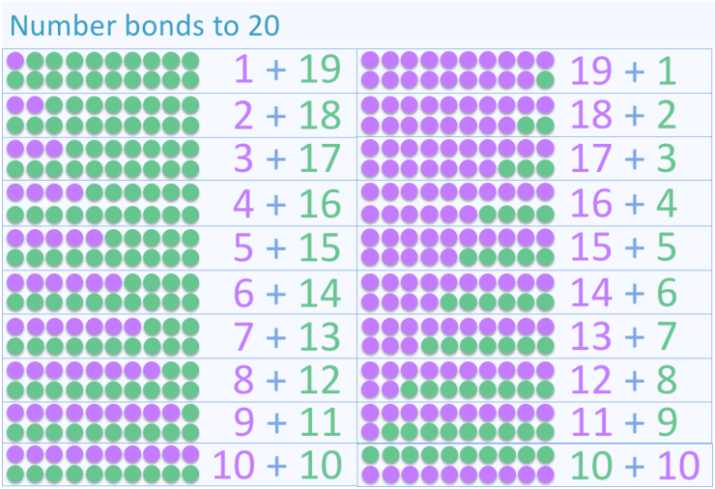  Questions to ask at home  - What do we need to add to 13 to make 20?  - If I have 10, how many more do I need to get to 20?  - What is the difference between 20 and 12? | Key Vocabulary  12 add 8 equals 20  18 plus 2 is the same as 20 20 take away 7 equals 13  20 subtract 3 makes 17  20 minus 9 equals 11
Odd and even numbers to 20.  Questions to ask at home  - What is the next even number after 8?  - Can you count in even numbers from 0 – 20?  - Starting at 1, can you say all the odd numbers to 20? | Key Vocabulary  odd  even

Top Tips
The secret to success is practising little and often. Use time wisely. Can you practise these KIRFs while walking to school or during a car journey?
Chants- Practice chanting the number bonds.
Paper Chains- Use two different colours to make paper chains to show each number bond, for example 14 + 6 could be shown as 14 green links and 6 blue links.
Say it, make it, write it- For each number bond, say it our loud, make it using everyday objects and then write it as a sum.
Pegs – Put 20 pegs on to a coat hanger, split them in different ways and count how many pegs are on each side. E.g. 14 pegs + 6 pegs = 20 pegs (14+6=10).
Websites:
White Rose video: Spring 1.2.5 Find and make number bonds. https://vimeo.com/490882337
Funky Mummy - Quick recall of addition, subtraction and multiplication facts (ictgames.com) https://www.ictgames.com/mobilePage/funkyMummy/index.html
Smoothie Maths Practise number facts to 10, then 20 (ictgames.com) https://www.ictgames.com/mobilePage/smoothie/index.html

