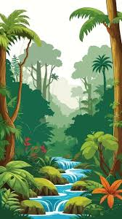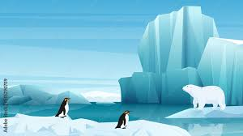 **Wonderful**

**World**

Choose from any of the ideas below, do as many as you would like or make up your own. **Have fun!**

* Create your own world or island. Does is have animals? What is it like? You could draw, paint or make a model out of junk, Lego or any other materials you have around your house.
* Design a flag for the world you created or practise drawing some of the flags of real countries. You could make some bunting!
* Research some fun facts about a country of your choice. Make an information leaflet or poster about the people, lifestyle, climate, food, landscape etc
* Design a poster showing the different continents in the world. Maybe you could include a drawing to represent each one. What different animals might you see in each continent?
* Write a story about a holiday you went on to a different country. Perhaps this could be a comic strip or a diary account either.
* Transport/Travel – you could research the different types of transport for travel. Draw a picture and write some facts about how popular each mode of transport is and why.
* Write a poem about a different country. It could be an acrostic poem using the name of the country as the title. What facts could you include?
* Find some pictures of different landscapes – tropical jungle, dessert, polar regions, under the sea. Could you sketch these or create a collage out of materials?

