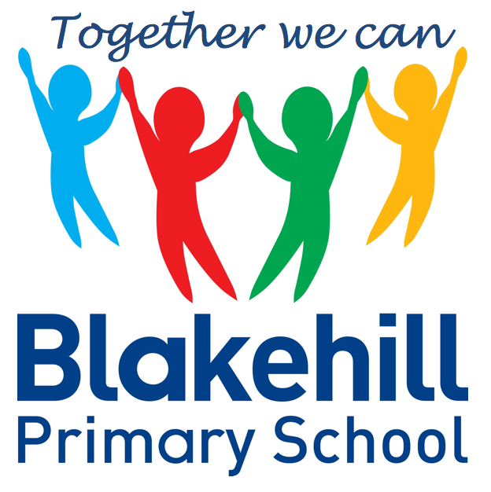
English
Our work this half term will be based around animal habitats. We will be writing about animals and the places in which they live. The children will be reading a book called ‘Leaf’ by Sandra Dieckmann, which highlights the plight of polar bears in today’s changing climate. The children will be writing their own stories based around the book.
- Geography Where in the world would you rather be? Fieldwork comparison between Bradford and Kenya.
- Art Collage and sculpture. Mother Nature- The children will mix materials to create texture. They will sort, arrange and use materials to design work around animals and their habitats.
- Science Living things and their habitats. The children will identify and name plants and animals. They will learn that plants and animals live in habitats and rely on each other. There will be a visit to the Yorkshire Wildlife Park- details to follow.
- DT Cooking and Nutrition. The children will be learning about where food comes from and will be designing and making a healthy snack.

Science, History, Geography, Art and D&T
- PSHCE – Being my Best
- RE Our World-The children will be learning about some of the threats to the environment and some of the animals that are in danger. We will be talking about what can be done to help. We will focus on Christianity, Judaism and Islam.

- Outdoor athletics
- Net and wall games
Outdoor PE is on Fridays. Indoor PE is on Mondays. Please ensure your child has their PE kits in school on these days, and that it is all clearly named.

- E safety- Online Bullying
- Data Handling
Show information as a simple block graph or pictogram.
Organise and interpret data as a simple graph
- To sort and answer questions using yes/no answers.

- Maths: Please help your child to learn the KIRFS for this half term. Details are on the class pages of the school website.
- Spellings: Spellings will be tested on a Monday.
- Reading: Read with your child as often as possible. Books are changed daily.
- Please ensure every day that your child has a water bottle, filled with water only please.
- Any money sent into school should be in named envelope. Thank you.
- The children will be doing their SATS assessments wb 16th May.

Other information
- How does music make us happy?
- Rock, film, Jazz, Popular/Jazz, Calypso
Half Term Curriculum Overview

- Properties of Shape
- Fractions
- Measurement- Length and Height
- Position and Direction
- Time, Mass, Capacity and Temperature

Mathematics
matics
PSHCE and RE
Physical Education
ICT
Music
Year 2 Summer 1 2022

