**Geography Vocabulary**

**Amazing Americas (Year 6)**

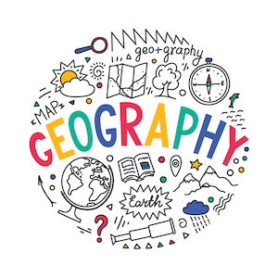

Mountains _______________________________________

temperate forests _________________________________

rainforests ______________________________________

deserts _________________________________________

tundra __________________________________________

plains and the Canadian Shield _________________________

biome ___________________________________________

climate zone ______________________________________

Koppen System ____________________________________

