Year 4
Why Settle Here?
Settlements based on natural resources
Links made with other subjects | History: Romans  Science: Living things/ Animals including humans  Residential: Nell Bank (Ilkley – Roman settlement)
The BIG Question | Why did the Romans settle in Ilkley?
The BIG Outcome | Children to answer the question, demonstrating the knowledge they have learnt during this unit. The children could use maps to support / evidence. This could be done as an oracy discussion. It could also include creating an estate agent type advert advertising Ilkley to Roman settlers.
Geography objectives  (link to NC) | - Identify human and physical characteristics, key topographical features (including hills, mountains, coasts and rivers), and land-use patterns; and understand how some of these aspects have changed over time.  - Describe and understand key aspects of human geography, including types of settlement: the distribution of natural resources including energy, food, minerals and water.  - Use maps, atlases, globes and digital/computer mapping to locate places and describe features studied.  - Use the eight points of a compass, four and six-figure grid references, symbols and key (including the use of Ordnance Survey maps) to build their knowledge.  - Use fieldwork to observe, measure, record and present the human and physical features in the local area using a range of methods, including sketch maps, plans and graphs, and digital technologies.
Prior knowledge  What prior knowledge is needed for children to be successful in this unit? | Children already know:  - Y1 – Town mouse, country mouse (and seaside mouse too) (Comparison of town, country and seaside)  - Y2 – Where would you rather be? (Comparison of UK and non-UK)  - Y3 – Oh, I do like to be besides the seaside. (Coastlines)  - Y3 - History: Stone age to Iron age
Future learning  Consider the conceptual knowledge within a subject that pupils need for future learning not just the recall of facts but the importance of concepts | This unit gives prior knowledge to:  - Y5 – Our Yorkshire. Comparing Idle and Clapham  - Y5 – History: Anglo Saxons  - Y6 – Rainforests  - Y6 – History: Vikings
Geographical strands | Geographical Skills  - To identify physical features on a map.  - Compare past and present maps.  - To use a four-figure grid reference on smaller scale maps eg. The town of Ilkley.  - Draw sketch maps using symbols to identify specific features.  Locational Knowledge  - To locate the River Wharfe on a map.  - To locate hills, areas of woodland and vegetation belts.  - To use the 8 points of a compass to talk about features in relation to each other.  Place Knowledge  - To know the needs of early settlers.  - To know that people settled in Ilkley because of the availability of natural resources.  - To know that people settled in Ilkley because it provided tactical benefits (e.g. a vantage point).  Environmental, human and physical geography  - To know that modern and roman settlements are different.  - To link the availability of resources to changes in settlements.  - To know that the relationship between land use and settlements has changed over time.
Vocabulary/ Glossary | Settlement, settler, shelter, land use, water, food, resources, woodland, river, vegetation belt, hills.
Knowledge  (see italics for knowledge to remember) | The knowledge that children will learn and remember:  - A settlement is a village, town or city where people live.  - Many of the places where people live today have existed for hundreds or even thousands of years. Created by early settlers to the UK: Romans, Vikings, Anglo-Saxons.  - London (Roman: Londinium), Leeds, Bradford (Saxon: Broad Ford)  - Place names show us who settled in an area and what it was like:  Roman Anglo Saxons Vikings  -chester = castle -caster = castle -cester = castle e.g. Manchester -ham = village -ton = farm -ford = river crossing - carr = bog e.g. Birmingham -by = village -thorpe = farm -toft = house e.g. Scunthorpe  - Early settlers needed shelter, water and food. This came from the landscape around them – woods, rivers, hills etc.  - Land is used in different ways in settlements (this is different for early settlers to modern settlers):  - housing  - agriculture - The farming of crops or animals.  - industrial - Businesses that provide products or services.  - leisure - Time spent away from work relaxing.  - retail - Shops selling products to people.  - Settlers consider the following:  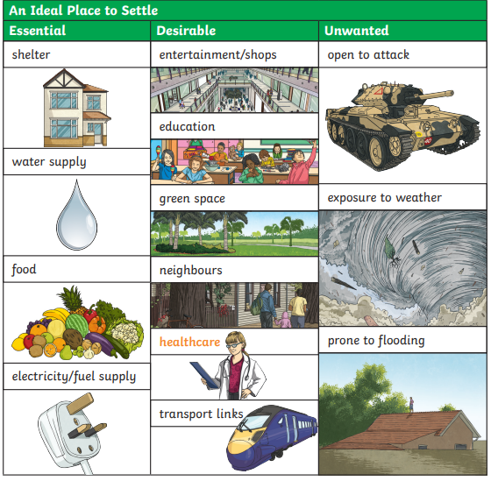  - Ilkley has been settled since the early Bronze Age - 1800 BC.  - There is a Roman fort near the town centre dating to 79 AD.  - The River Wharfe in Ilkley was a necessary resource for early settlers local to us. It provided water, food, transport.  - Being on a hill made it an ideal place for a settlement (Roman fort).  - Woodland provided food, clothing and fuel.
SEND expectations | - A settlement is a village, town or city where people live.  - Early settlers needed shelter, water and food. This came from the landscape around them – woods, rivers, hills etc.  - Settlers look for shelter, water supply, food, and fuel.
Teaching ideas/ resources | - Use maps to identify local names of places that may have been early settlements.  - Use maps to identify where might be a good place to settle.
Suggested Teaching Sequence | Session One  Points 1, 2, 3 and 4. Children will know what a settlement is. They will learn key vocabulary to do with settlements and will find examples on a map.  Session Two  Point 5, 8, 9, 10, 11 and 12. Children will know what early settlers looked for.  Session Three  Points 6. Children will know what a modern settlement looks like.  Session Four  Point 7. Children will identify ideal areas to settle and justify why.  Session Five: Assessment

