**Art Vocabulary**

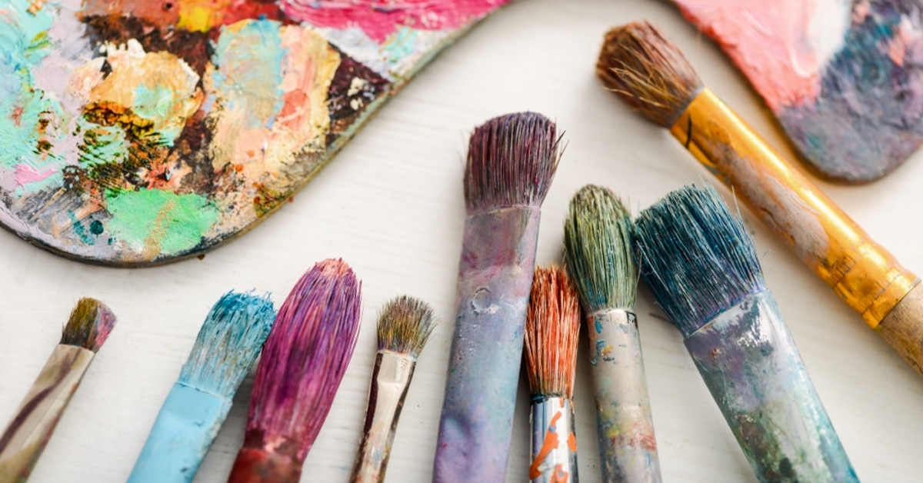

pencil pens chalk mark making

pincer grip (froggy fingers)

draw line shape feeling colour illustrator illustrate

pallet brush colour shade mix thick thin tools shapes assemble

glue scissors sellotape string paper clips paper fasteners staples treasury tags tall short long big small