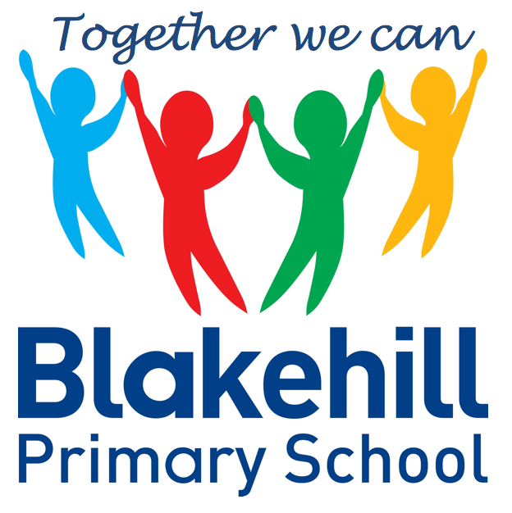
Personal, Social & Emotional
Children will be taking part in weekly circle times. They will have the opportunity to talk about themselves and their family. Children will be encouraged to take turns and listen to each other. We will also be talking about our wider school family, our school Golden Rules, good manners and how to be a good friend. We will continue to work on personal hygiene, such as regular handwashing and looking after our teeth.

Reading and Writing
This half term our topic will be ‘Amazing Animals.’ We will be learning all about:
Life cycles
Animals around the world
Climates/hibernation
Down on the farm
Minibeasts
Animal art and crafts
Night and day animals
Animal patterns
.

Understanding of
the World
We start each morning with Go Noodle or Supermovers to get active and use ‘Dough Disco’ to work on our fine motor skills. There are daily opportunities for children to play outside and every Friday children will do PE with our PE coach. Please could we again ask that children practise putting on and fastening their coats independently at home.

This half term we will continue to practise and apply the Phase 3 sounds and tricky words. We will revisit all the sounds taught so far and we will continue to support any children who are not yet confident with Phase 2 sounds. Children should now be working hard to blend sounds together to make words and should be able to recognise some tricky words on sight.

Children will have the chance to work creatively every day in our areas of indoor and outdoor provision. There will be weekly music sessions with Mrs Brown. This half term children will be taking part in the ‘Big Bear Funk’ unit of work – this will help prepare the children for their musical learning in Year 1. They will also be exploring sounds and will have the opportunity to use different musical instruments.

Book Bags- Please remember that your child needs to bring their book bag to school every day.
Water bottles- Please make sure that your child has a clearly named water bottle in school every day and that this contains only water. Please don’t transport your water bottle in your book bag as the water can damage the reading books if they leak.
PE kit- Please ensure your child has their PE kit in school every Friday.
Zoolab Visit – Thursday 19th May 2022 – Please consent and pay on Parent Pay by 6.5.2022

Other information
Half Term Curriculum Overview

Mathematics
Physical Development
Phonics
Expressive Art & Design
Reception Summer 1 Term 2022 – Amazing Animals

We will continue to have a daily maths session after lunch. Our topics for this half-term will be:

Growing 6,7,8 - Making Pairs, Combining 2 groups, Adding More, Comparing height and length
Time – now, before, later, soon, after, then, next, yesterday, today, tomorrow, days of the week.
Building 9 and 10 - Counting, representing and subitizing 9 and 10. Use of 10 frames to explore composition. Comparing numbers to 10. Bonds to 10. 3D Shape. Pattern.
To 20 and Beyond - Consolidation of key skills: Subitising,
Counting, Composition, Sorting and Matching, Comparing and Ordering. Building numbers beyond 10. Counting patterns beyond 10. Spatial Reasoning: Match, rotate, manipulate

You can help your child at home by identifying and talking about numbers and shapes in the environment and by practising the formation of numbers.

The children will continue to bring home a phonics based book to read. Please ensure your child keeps their reading record in their book bag. Children will be encouraged to use their phoneme fingers to sound out and blend words using their phonic knowledge. Please continue to share a book with your child every day if possible. In writing children will be again encouraged to use their phoneme fingers to sound out and write simple words and sentences using phonic knowledge and the tricky words learnt so far. They will also be taught to use finger spaces and full stops consistently.
We will continue to practise daily name writing and correct letter formation and again it would help to practise this at home. Your child’s names should start with a capital letter, but the rest of the letters should be lower case.

