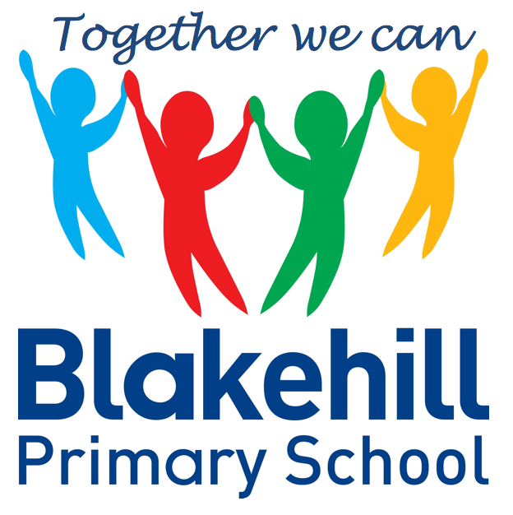
Personal, Social & Emotional
Children will be taking part in weekly circle times. They will have the opportunity to talk about themselves and their family. Children will be encouraged to take turns and listen to each other. We will also be talking about our wider school family and our school Golden Rules. We will continue to work on personal hygiene, such as regular handwashing and looking after our teeth.

Reading and Writing
Most children this half-term will bring home a phonics based book to read. Please ensure your child keeps their reading record in their book bag. Children will be encouraged to use their phoneme fingers to sound out and blend words using their phonic knowledge. Please continue to share a book with your child every day if possible and also to practise reading any sets of high frequency words sent home.
In writing children will be again encouraged to use their phoneme fingers to sound out and write simple words. We will continue to practise daily name writing and correct letter formation and again it would help to practise this at home. Your child’s names should start with a capital letter, but the rest of the letters should be lower case. In writing we will also be encouraging children to use finger spaces.

This half term we will be travelling all around the world and finding out about the cultures, features and wildlife in different places. We will begin by talking about features of our own immediate environment, with a fieldwork study of our school. We will then move on to looking at the country we live in and the wider world. This will include a visit to China for Chinese New Year. Later on in the half-term we will have a visit by Zoolab when children will encounter different types of animals. We will also be looking at the changing seasons.

Understanding
the World
We start each morning with BBC Supermovers to get active and use ‘Dough Disco’ to work on our fine motor skills. There are usually daily opportunities for children to play outside and every Friday children will do PE with Mr Simmons, our PE coach. Please could we again ask that children practise putting on and fastening their coats independently at home.

This half term begins with the teaching of tricky words. We will then move on to Phase 3 phonics, which includes the teaching of some digraphs ( two letters making one sound, eg ch ). There will be a catch up programme for the children who are not yet confident with Phase 2 sounds. Children should now be beginning to blend sounds together to make words.

Children will have the chance to work creatively every day in our areas of indoor and outdoor provision. There will be weekly music sessions with Mrs Bottomley. This half term children will again be singing familiar songs and nursery rhymes. They will also be exploring sounds and will have the opportunity to use different musical instruments.

Book Bags- Please remember that your child needs to bring their book bag to school every day.
Water bottles- Please make sure that your child has a clearly named water bottle in school every day and that this contains only water. Please don’t transport your water bottle in your book bag as the water can damage the reading books if they leak.
PE kit- At the current time your child just needs to come to school in their PE kit each Friday.

Other information
Half Term Curriculum Overview

We will continue to have a daily maths session after lunch. Our topics for this half-term will be:

Light and Dark - Four / Five / One more and one less / Shapes with four sides /
Night and day

Alive in 5! - Introducing 0 / Comparing numbers to 5 / Composition of 4 and 5 / Comparing mass / Comparing Capacity

You can help your child at home by identifying and talking about numbers and shapes in the environment and by practising the formation of numbers.

Mathematics
Physical Development
Phonics
Expressive Art & Design
Reception Spring 1 Term 2021 – Around the World

