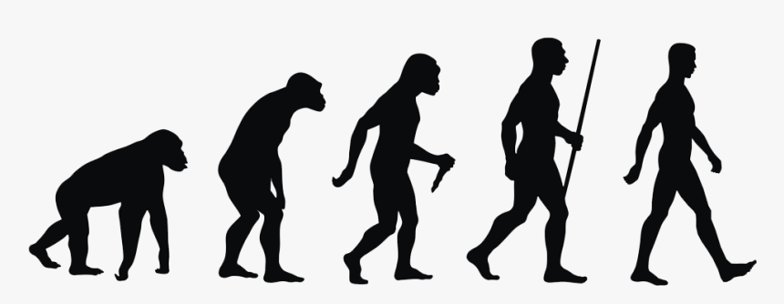

Any other words:

**Science Vocabulary**

**Evolution and inheritance**

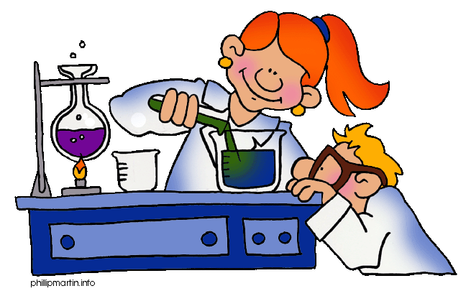

**Y6: Evolution and inheritance (animals, including humans)**

Offspring, sexual reproduction, vary, characteristics, suited, adapted, environment, inherited, species, fossils