To know decimal number bonds to 1 and 10.
By the end of this half term, children should know the following facts. The aim is for them to recall these facts instantly.
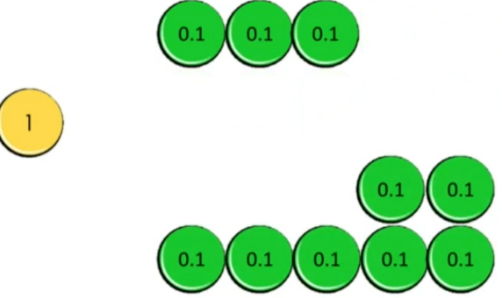  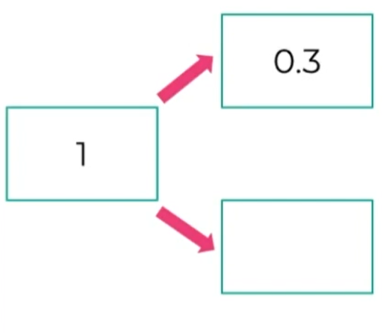 | Key Vocabulary  How many more to make?  Altogether  Make  Sum  Total  How much more is _ than _?  Difference between
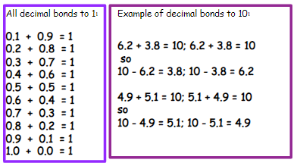

Top Tips
The secret to success is practising little and often. Use time wisely. Can you practise these KIRFs while walking to school or during a car journey? You do not need to practise them all at once; perhaps you could have a fact of the day.
Play cards: Remove picture cards and the 10s. Play snap, treating each cars as tenths. When you have a pair which total 1, shout snap and explain why e.g. 0.2 + 0.8 = 1
Dominoes: Pick a domino from a set facing down. Choose one side to represent the whol number and the other side to be the tenth. Ask how much more to make 10. E.g. picture shows 5.2, so 4.8 more makes 10.
Call out!: Play number ping pong! Start by saying ‘ping’, child replies with ‘pong’. Repeat and then convert to numbers e.g. ‘0.3’ and they reply ‘0.7’ (decimal bonds to 1)

