**Y5: Life cycles (animals, including humans / living things and habitats)**

Life cycle, reproduce, sexual, sperm, fertilises, egg, live young, metamorphosis, asexual, plantlets, runners, bulbs, cuttings

Puberty – the vocabulary to describe sexual characteristics

**Y4: Grouping living things (living things and habitats)**

Classification, classification keys

**Year 2: Habitats (living things and habitats)**

suited, suitable, basic needs, shelter

Names of **local** habitats e.g. urban, pond, oak woodland, river Corridors (River Aire), In Bye Pasture (Esholt/North Street Farm), hedgerows.

• Names of micro-habitats e.g. under logs, in bushes, in hedgerows, healthy, germinate

Change or delete for younger year groups.

**Y6: Classifying living things (living things and their habitat)**

Vertebrates, fish, amphibians, reptiles, birds, mammals, invertebrates, insects, spiders, snails, worms, flowering, non-flowering.

**Y4: Dangers to living things (living things and habitats)**

environment, habitat, human impact, positive, negative, migrate, hibernate  
herbivore, carnivore, omnivore, producer, predator, prey, food chain

**Science Vocabulary**

**Living things and their habitats**

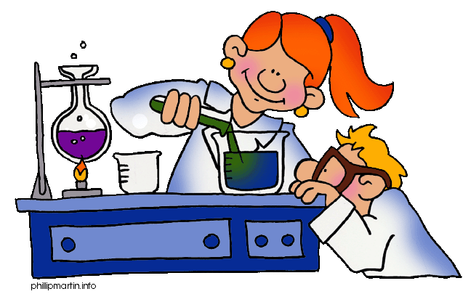

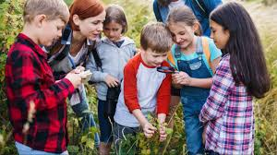

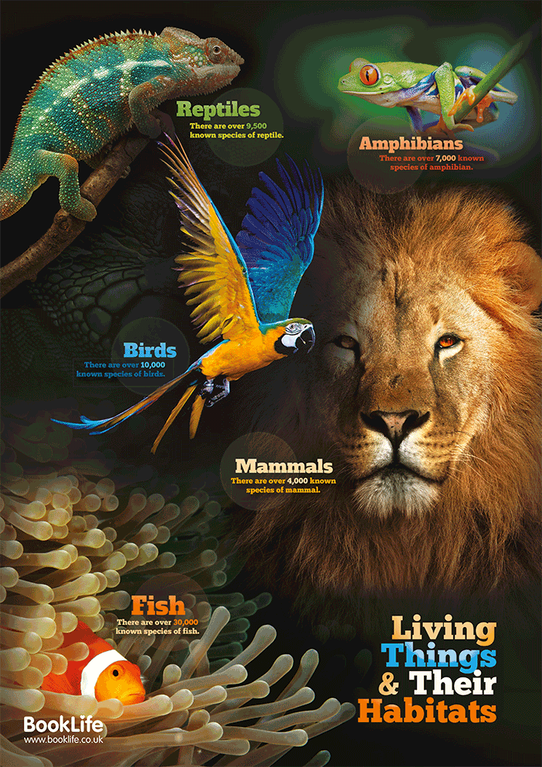

**Any other words:**