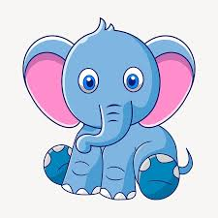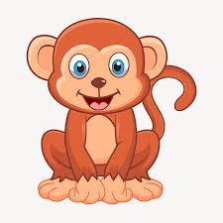 **Amazing Animals**

Choose from any of the ideas below, do as many as you would like or make up your own. **Have fun!**

* Create your own animal. How many legs does it have? Where will it live? Will it have fur? You could draw, paint or make a model out of it from junk, Lego or any other materials you have around your house.
* Research some fun facts about your favourite animal. Make an information leaflet or poster about the animal, sharing facts about their appearance, habitat, lifecycle, food etc
* Design a poster showing how to care for a pet. This could help someone who is getting a pet for the first time.
* Write a story where all the characters are animals. What could the problem be? How might they solve it? You could represent this as a comic strip either and add some speech.
* Write some of your own word problems to do with animals. We might try and solve them next week in Maths lessons.
* Write a poem about an animal. It could be a shape poem like we did last half term or an acrostic poem. Some illustrations would be nice here too.
* Find some pictures of different animals and sketch their different body shapes. Perhaps you can add some colour. You might prefer to sketch some cartoon animals either - there will be lots of pictures online.
* Create an animal out of junk or anything in your recycling bin at home. It could be a real animal or one you’ve made up yourself!

