Year 5
Greek structure
Links made with other subjects | History – The Ancient Greeks  Maths - Measurement
The BIG Question | Can you design and make a Greek inspired building?
The BIG Outcome | To make a stable Greek structure using recycled materials
DT objectives  (link to NC) | Design  - Design purposeful, functional, appealing products for themselves and other users based on design criteria  - Generate, develop, model and communicate their ideas through talking, drawing, templates, mock-ups and, where appropriate, information and communication technology  Make  - Select from and use a range of tools and equipment to perform practical tasks [for example, cutting, shaping, joining and finishing  - Select from and use a wide range of materials and components, including construction materials, textiles and ingredients, according to their characteristics  Evaluate  - Explore and evaluate a range of existing products  - Evaluate their ideas and products against design criteria  Technical knowledge  - Build structures, exploring how they can be made stronger, stiffer and more stable  - Explore and use mechanisms [for example, levers, sliders, wheels and axles], in their products.
Prior knowledge  What prior knowledge is needed for children to be successful in this unit? | This unit builds on:  Reception – Design and make a boat  Year 1 – Design and make a castle  Year 2 – Design and make a house  Year 3 - Design and make a Stone age roundhouse  Year 4 – Design and make a package
Future learning  Consider the conceptual knowledge within a subject that pupils need for future learning not just the recall of facts but the importance of concepts | This unit gives knowledge to:  Year 6 – Design and make a fairground ride
DT strands | Design  - Design purposeful, functional, appealing products for themselves and other users based on design criteria  - Generate, develop, model and communicate their ideas through talking, drawing, templates, mock-ups and, where appropriate, information and communication technology  Make  - Select from and use a range of tools and equipment to perform practical tasks [for example, cutting, shaping, joining and finishing]  - Select from and use a wide range of materials and components, including construction materials, textiles and ingredients, according to their characteristics  Evaluate  - Explore and evaluate a range of existing products  - Evaluate their ideas and products against design criteria  Technical knowledge  - Build structures, exploring how they can be made stronger, stiffer and more stable  - Explore and use mechanisms [for example, levers, sliders, wheels and axles], in their products.
Vocabulary/ Glossary | Designing, constructing, buildings, measure, beam, sturdy, pillar, cut, shape, support, structure, stronger, technique, columns, roof, wide, tall, Doric, Ionic, Corinthian, Doric, thick, plain, flat, grooves, thin, scroll, edge.
Knowledge  (see italics for knowledge to remember) | The knowledge that children will learn and remember:  - Investigate and analyse a range of existing products.  - What makes a structure stable?  - Investigate and look at a range of Greek Architecture – Parthenon, temples, open-air theatres and buildings with Doric, ionic and Corinthian columns.  - Name the materials in which the buildings have been constructed from. Why were they used? Children to think about the materials which were available.  - Why do you think that other materials such as wood might not be so good for these types of structures?  - Show the children the PowerPoint of Ancient Greek architecture.  - We will be designing a structure like this using recycled materials – What are recycled materials? which materials will be best to use? Why?  - Children to write and explain the best materials to use.  2. Generate, develop, model and communicate their ideas through discussion and annotated sketches.  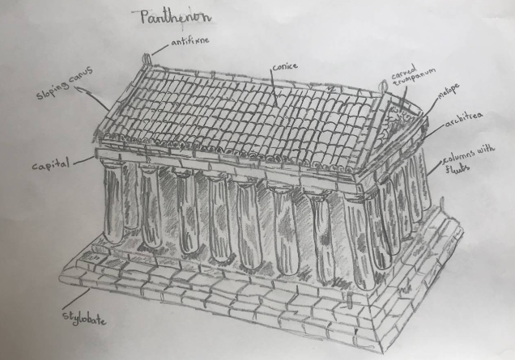  - Children to use the iPads/Chromebooks to investigate historic Greek structures and buildings.  - Children to design their own Greek inspired building in their topic book. Children must create a 3D sketch of how their structure will look and annotate this using accurate vocabulary (column/pillars)  - Include and name recycled materials that their structure is going to be made from.  - Before designing a Greek structure, we need to write design criteria.  - What must the design structure do? What is it going to tell us?  - Which materials will you use for your bridge design?  - Show what materials and tools may be used in the construction of the prototype.  - Write a design criteria then design and build a prototype column according to those criteria.  (Children to practise making a column. How can we support this column to stand on it’s own? Children to think, pair, share their ideas.)  - Why might each Greek building that you will design look different? Children to think about different materials being used – recycled materials (plastic, paper, wood, cork) are all different and will create a different look and will need to be cut and shaped differently from one another.  3. Select and use tools suitable for the task, explaining their choices, to cut, shape and join materials.  - Children to select and use a range of recycled materials.  - Discuss the use of recycled materials, why are we using them? (Sustainability)  - Use a range of tools and equipment to perform practical tasks accurately.  - Gather all of the equipment and materials that they will need.  - Use simple finishing techniques suitable for the product they are creating.  - Know and explain how to create a stable structure (children to think and talk through how their structure stands and what holds it together.)  - How was your structure put together/ Which resources worked best to hold your building?  - Evaluate their product by discussing how well it works in relation to the purpose and the user and whether it meets the design criteria.  - What have we been making? What are they designed to do? How will we know if our product is successful?  - Write a list of things a stable structure, like a building, should be able to do. Then add any ideas. How will we know if our structure meets these requirements?  - Children to test their products to see if they function as stable structures and then they will evaluate them.  - What worked well? What didn’t work well? How could you improve if you were to given instructions to your friend on how to make this building?
SEND expectations | - To know what a Greek building is, how it is constructed and what they are made from.  - To know different types of materials that Greek buildings are constructed from.  - To know how a Greek building is built, thinking about precise measurements and stability.  - To know which tools and equipment to use and why.  To know and explain how to create a stable structure.
Websites to support this unit | https://www.stvincentsprimary.org.uk/blog/design-technology-greek-architecture/  https://www.bbc.co.uk/bitesize/topics/z87tn39/articles/zgpdjxs

