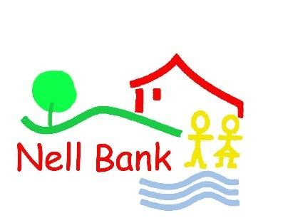
NELL BANK

NIGHT RESIDENTIAL KIT LIST
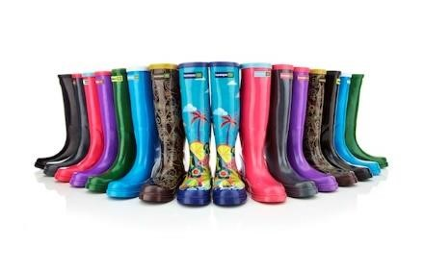
Day Bag / Rucksack

hat scarf gloves coat (waterproof) lunch water bottle (with water in it) sun cream old trainers for walking Wellies (can be provided by Nell Bank)

Layers are vital to keep warm on the long walk to Ilkley Moor.

Note: scarves, gloves & sun-cream are weather-dependent.
OLD TRAINERS or Walking boots/shoes for the Walk

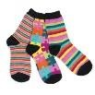
Overnight Bag (small enough for child to carry)

indoor shoes |  | 2 x trousers |  | 3 x t-shirts/shirts
2 x jumpers |  | 1 x fleece |  | 4 x socks
4 x underwear |  | towel |  | toothbrush
toothpaste |  | hairbrush |  | soap/shower gel
pyjamas |  | Fitted sheet |  | sleeping bag/duvet and cover
Pillow and pillow case
Also a torch if possible as we might go on a walk around Nell bank in the dark.

Note: there is no shop at Nell Bank so spending money is not required.

Medication (inhalers, epi-pens etc)
If your child needs medication, please take it to the school office prior to the residential and fill out a medical form.
On the Day (Wednesday 11th October)
Please have your child in school for the normal time of 8:45. We shall be departing at around 11am. On the day please send your child to school with a packed lunch, if you haven’t ordered one from the school kitchen. On the Thursday and Friday, a packed lunch will be provided for them.

We shall return to Blakehill around 1pm on Friday 13th October and children can be collected at the end of the school day – 3:15pm.

