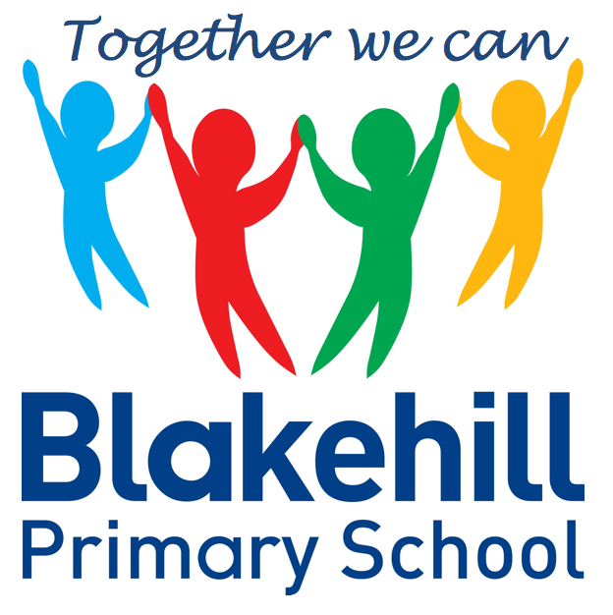
Personal, Social & Emotional
Once all children are in school we will be focusing on supporting their wellbeing and mental health and have a lovely story to support this. More information will follow.
Children will be taking part in weekly circle times. They will have the opportunity to talk about their family. Children will be encouraged to take turns and listen to each other.
Writing
During this half term, we will begin focused phonics teaching every day. To begin with, we will focus on listening and speaking skills, rhyme, looking at instruments, alliteration and environmental sounds.
When the majority of children are secure in these skills we will begin to teach the individual graphemes (letters). We aim to teach one new grapheme each day. The children will learn the sound that the grapheme makes (phoneme) using songs and actions. The first set of graphemes we will learn are, s,a,t,p,i,n, m and d. When the children know these sounds they will start to blend them to make words.

This half term we will be talking about features within the immediate environment and discovering what our school environment is like by going on a ‘Sensory Walk’. We shall be identifying similarities and differences between ourselves and others. Talking about our own lives and that of family members and also begin to know that some things have happened and somethings are happening now – focusing on how time moves on.

Understanding
the World
There will be many opportunities for children to play outside during this half term. In class we will focus on fine motor skills and develop pencil grip and control. Every Friday they will do PE with Mr Simmons.
Children will bring home a story book along with their reading diary daily during this half term. When focussed phonics teaching begins this will become a phonics based book which the children will be able to begin to read more independently.
Children will have the chance to work creatively in our continuous provision on a daily basis. There will be weekly music session with Mrs Carter. This half term children will be singing familiar songs and nursery rhymes. They will be exploring sounds and will have the opportunity to use different musical instruments.

Book Bags- Please remember that your child needs to bring their book bag to school every day.
Water bottles- Please make sure that your child has a clearly named water bottle in school every day. Please don’t transport your water bottle in your book bag as the water can damage the reading books if they leak.
PE kit- Following COVID guidance we are asking children to come to school dressed in their PE clothes on the day of the lesson. They will remain in these clothes for the whole day. As we are now entering the cooler months, they will need to be in an outdoor PE kit: black/navy jogging bottoms and either a zip-up hoodie or their school sweatshirt over a white T-shirt. They will also need to wear trainers – please make sure these are Velcro fasteners. Their PE day is every Friday. We shall let you know when we begin outdoor PE.

Other information
Half Term Curriculum Overview

We will be have a maths session every day. We will count aloud daily to 30. When we count, we touch our head for every even number and our nose for every odd number. This helps the children in the future to understand the concept of odd and even numbers.
We will support the children in matching, sorting and comparing amounts. We will also be comparing size, mass, capacity and exploring patterns.
Mathematics
Physical Development
Reading
Expressive Art & Design
Reception Autumn 1 Term 2020

