**Y3: Parts of plants (plants)**

Stems/trunks, leaves, flowers/ blossom, roots, nutrients, Photosynthesis, pollen, insect/wind pollination, seed formation, seed dispersal (wind dispersal, animal dispersal, water dispersal)

**Y3: What plants need (plants)**

Leaf, flower, blossom, petal, fruit, berry, root, seed, trunk, branch, stem, bark, stalk, bud, evergreen, deciduous, light, shade, sun, warm, cool, water, grow, healthy, germinate

**Year 1: Plants (plants)**

Leaf, flower, blossom, petal, fruit, berry, root, seed, trunk, branch, stem, bark, stalk, bud, evergreen, deciduous, Birch, Holly, Hawthorn, Oak, Conifer, Beech, Sycamore, Alder, Hornbeam, Scotts Pine, roses, bluebells, tulips, snowdrops

**Year 1: Changing seasons (plants)**

Weather (sunny, rainy, windy, snowy etc.)

- Seasons (winter, summer, spring, autumn)

- Sun, sunrise, sunset, day length

**Science Vocabulary**

**Plants**

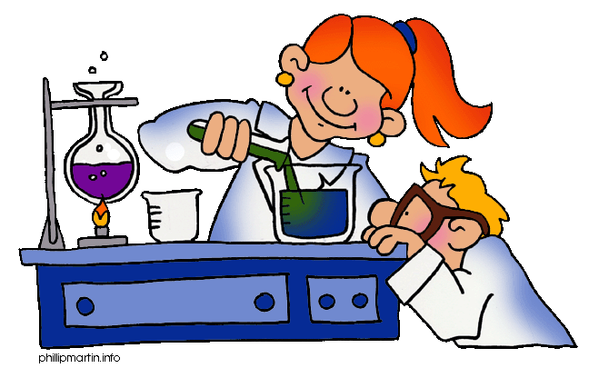

Any other words:

**Year 2: Growing plants (plants)**

light, shade, sun, warm, cool, water, grow, healthy, germinate

