To add 10 to any number.

To know all doubles and halves of even numbers to 10.

By the end of this half term, children should know the following facts. The aim is for them to recall these facts instantly.

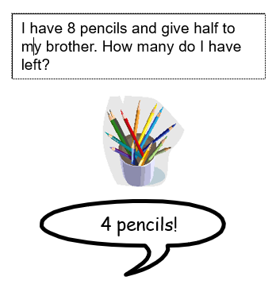 | Doubles & Halves:  4 doubled is 8  4 halved is 2  6 doubled is 12  6 halved is 3  10 doubled is 20  10 halved is 5 | 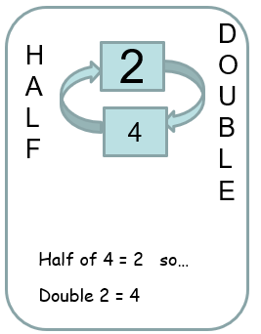 | Key Vocabulary  double  halve the number  half of…  even

Top Tips
The secret to success is practising little and often. Use time wisely. Can you practise these KIRFs while walking to school or during a car journey?
Use practical resources - Your child has 6 pieces of lego. What would double 6 be?
https://www.ictgames.com/mobilePage/archeryDoubles/index.html Robin Hood Archery Doubles interactive game
https://www.topmarks.co.uk/maths-games/hit-the-button Select either doubles or halves

