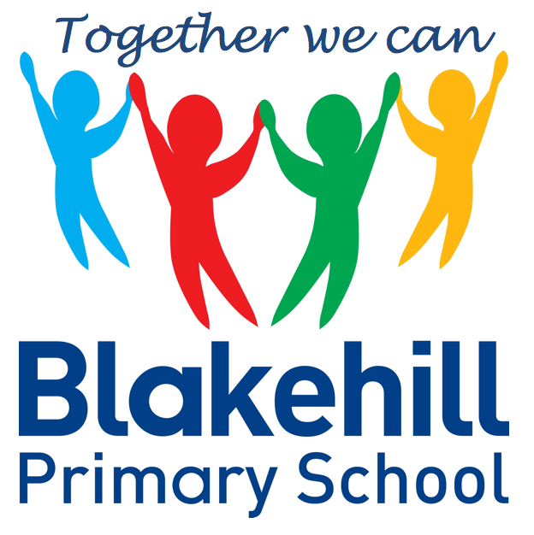
Personal, Social & Emotional
Children will be taking part in weekly circle times. They will have the opportunity to talk about themselves and their family. Children will be encouraged to take turns and listen to each other. We will also be talking about our wider school family, our school Golden Rules, good manners and how to be a good friend. We will be doing lots of transition work to prepare children for their move into Year 1.

Reading and Writing
The children will continue to bring home a phonics based book to read, at the level they are working. Please ensure that their reading book and reading record are kept in their book bag. They will get a sticker on their Rainbow Reading Challenge Chart for each comment you make in their Reading Record. Children will be encouraged to use their phoneme fingers to sound out and blend words using their phonic knowledge and may now be recognising many words on sight. Please continue to share a book with your child as often as possible. In writing children are being encouraged to write simple sentences, using finger spaced and full stops. Again they should use their phoneme fingers for spellings and draw on their knowledge of tricky words. We are working hard on letter formation and teaching the four families of letters.
We will begin this half-term completing our Once upon a tune work on Peter and the Wolf and also our life cycles work with the arrival in school of our caterpillars! Much of our work will then be related to our visit to Thornton Hall Farm on 16 June and will include: making observations, talking about similarities and differences, noting how things change and showing care and concern for living things and the environment. We will then move on towards the end of term to looking at properties of materials.

Understanding of
the World
We start each morning with Go Noodle to get active and use ‘Dough Disco’ to work on our fine motor skills. There are daily opportunities for children to play outside and every Friday children will do PE with our PE coach. Please could we again ask that children practise putting on and fastening their coats independently at home.

This half term we will continue to practise and apply Phase 3 sounds and tricky words. We will consolidate our skills by moving on to Phase 4, but children who are not yet secure in Phase 2/Phase 3 sounds will take part in booster interventions. Children should now be more confident in blending most sounds and recognising many tricky words on sight.

Children will have the chance to work creatively every day in our areas of indoor and outdoor provision. There will be weekly music sessions with Mrs Carter. This half term children will again be singing familiar songs, nursery rhymes and action songs. They will also be exploring sounds and will have the opportunity to use different musical instruments.

Book Bags- Please remember that your child needs to bring their book bag to school every day.
Water bottles- Please make sure that your child has a clearly named water bottle in school every day and that this contains only water. Please don’t transport your water bottle in your book bag as the water can damage the reading books if they leak.
PE kit- Please ensure that your child has their PE kit in school every Friday.
16 June 2022 – Visit to Thornton Hall Farm.
24 June 2022 – Sports Day

Other information
Half Term Curriculum Overview

We will continue to have a daily maths session after lunch. Our topics for this half-term will be:

To 20 and Beyond - Consolidation of key skills: Subitising,
Counting, Composition, Sorting and Matching, Comparing and Ordering. Building numbers beyond 10. Counting patterns beyond 10. Spatial Reasoning: Match, rotate, manipulate

First, Then, Now – Consolidation of key skills, Adding more, Taking Away and Spatial Reasoning.

Finding My Pattern – Consolidation of key skills, Doubling, Sharing and Grouping, Even and Odd and Spatial Reasoning.

On the Move - Deepening Understanding ( Problem Solving and Critical Thinking ), Patterns and Relationships and Spatial Reasoning
Mathematics
Physical Development
Phonics
Expressive Art & Design
Reception Summer 2 Term 2022 – Down on the Farm

