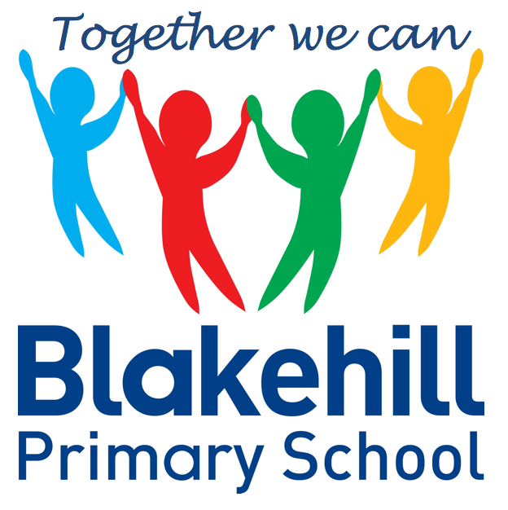
English
Our work this half term will be based around the books ‘Lost and Found’ by Oliver Jeffers, in which a penguin gets lost.
The children will be writing their own stories about a different animal character who gets lost. To help with this you can talk to your child about different animal habitats and what they may look like.
The children will also be learning about and writing about the South Pole and penguins.
The children will be writing some poetry about animals

- Geography We will be learning about physical and human features of the South Pole. Find the South Pole on a world map and see what you can discover about it. What animals live there? The children will be learning about the 7 continents and 5 oceans of the world.
- Art The children will be investigating shades as they mix colours for their paintings. They will learn how to make colours darker and lighter. We will be investigating watercolour paints. The children will be using collage to create animal habitat pictures. We will also be looking at the work of Monet, and painting Water Lilies.
- Science The children will be learning about living things and habitats. They will identify and name animals, and describe how they obtain their food. We will also be learning about food chains.
- DT The children will be investigating floating and sinking. They will also be designing and making a model boat that floats!
- DT Cooking and Nutrition. The children will be using the principles of a healthy and varied diet to prepare dishes and understand where food comes from.

Science, History, Geography, Art and D&T
- PSHCE Living in the wider world, economic well-being and being a responsible citizen.
- RE Our World. The children will be learning about some of the threats to the environment and some of the animals that are in danger. We will be talking about what can be done to help.

- Outdoor games
- Athletics
Outdoor PE is on Fridays. Indoor PE is on Mondays. Please ensure your child has their PE kits in school on these days, and that it is all clearly named.

- Computer science- Applying skills to other areas of the curriculum
- E safety
- Research using safe websites- The children will be using the internet to find out about the South Pole
- Information Literacy

- Maths: KIRFS will be given to the children and will be tested weekly.
- Spellings: Spellings will be tested on a weekly basis.
- Reading: Read with your child as often as possible. Books are changed when necessary.
- Please ensure every day that your child has a water bottle, filled with water only please.
- Any money sent into school should be in named envelope. Thank you.

Other information
- We will be learning about the musician Prokofiev.
- We will be playing musical instruments to accompany’ 'Peter and the Wolf’
Half Term Curriculum Overview

- Geometry: Properties of Shape
- Number: Fractions
- Measurement:
Movement and Turns, Time, Mass, Capacity and Temperature
- Geometry: Position and Direction
- Problem Solving
- Consolidation of work

Mathematics
PSHCE and RE
Physical Education
ICT
Music
Year 2 Summer 1 2021

