Year 2
Where in the world are we?
Locational knowledge about our world.
Links made with other subjects | Science: Living things and their habitats  Music: Zoo time  Computing: Information Literacy  English: Meerkat Mail
The BIG Question | What does our world look like?
The BIG Outcome | Children draw / complete their own sketch map of the world and populate with continents, oceans, landmarks and animals demonstrating the knowledge they have learnt this unit. This could also include sorting pictures in relation to continents / oceans for some pupils.  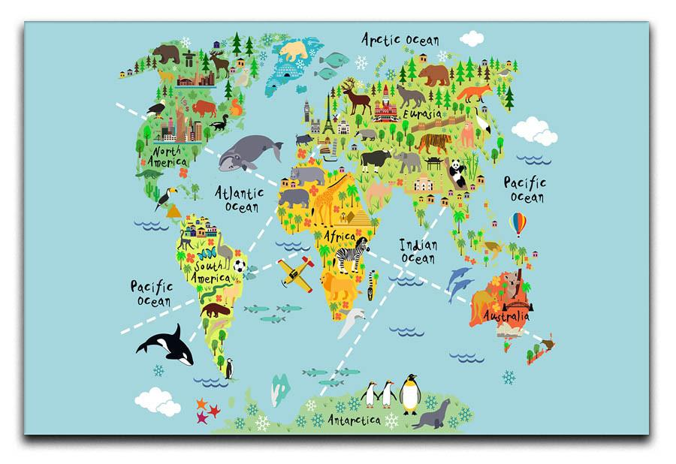
Geography objectives  (link to NC) | - Name and locate the world’s seven continents and five oceans.  - Use world maps, atlases and globes to identify the continents and oceans.  - Use basic geographical knowledge.
Prior knowledge  What prior knowledge is needed for children to be successful in this unit? | Children already know:  - Y1- Who are we and where are we? The UK
Future learning  Consider the conceptual knowledge within a subject that pupils need for future learning not just the recall of facts but the importance of concepts | This unit gives prior knowledge to:  - Y3 – Volcanoes and Earthquakes.  - Y4 – The Journey to the Sea. Rivers  - Y6 – Why are rainforests important? Rainforests  - Y6 – Amazing Americas.
Geographical strands | Geographical Skills  - Use world maps to label and annotate the seven continents and five oceans.  - Use the compass directions to describe the location of features on a map.  Locational Knowledge  - Know the equator and the North and South Poles.  - Know what the seven continents are.  - Know what the five oceans are.  Environmental, human and physical geography  - Know the key characteristics of each continent.  - Know human threats in some of our continents (Antarctica, South America)
Vocabulary/ Glossary | Continents, Oceans, Africa, Europe, Asia, Antarctica, Australasia, North America, South America, north pole, south pole, equator.
Knowledge  (see italics for knowledge to remember) | The knowledge that children will learn and remember:  - The equator is an imaginary line that goes around the middle of the world. It cuts our world in half into the north hemisphere and the south hemisphere. It is halfway between the North Pole and South Pole.  - The North Pole is at the very top of our world. The South Pole is at the very bottom of our world.  - Continent: a vast expanse of land often made up of lots of different countries. There are seven continents. They are: Europe, Africa, Asia, Australia, North America, South America  - Europe is the continent we live in. The climate changes depending on where you are. Key landmarks include: The Alps, Pyrenees, Eiffel Tower and Leaning Tower of Pisa. In Southern Europe the climate can be warm and sunny. In Northern Europe the climate can be rather cool. There is a lot of woodland in Europe. Animals: bats, badgers, toad, adder, hedgehog, deer.  - Africa stretches across the equator. Most of the continent is hot but it has deserts and rainforests. Key Landmarks are: the Pyramids, The Sahara Desert, The River Nile and Victoria Falls. It is in the middle of the Atlantic Ocean and the Indian Ocean. It is made up of deserts, rainforests and savannahs. Animals: Lion, meerkat, buffalo, giraffes, African Elephant, rhinos.  - Asia has a land border with Europe. It has most of the world’s population. Key landmarks: The Himalayas, Mount Everest and The Great Wall of China. It has Russia which is in two continents (Europe and Asia). It has about 60% of the world’s population. It has rainforests, mountain ranges, rice terraces and steppe (flat grassland with no trees). It contains the world’s tallest mountain (Mount Everest). Animals: Giant Panda, Hummingbird, Orangutan, Asian Elephant.  - Australia is the smallest continent in the world. It is the island continent. Key Landmarks: The Great Barrier Relief, Uluru and Sydney Opera House. Because it has been cut off from all other land for a long time, it has got lots of unique plants and animals. It is made up of outback, desert, mountains and rainforest. Animals: koala, kangaroo, platypus, wallaby, Tasmanian devil.  - Antarctica is the frozen continent. Key landmarks: McMurdo research centre, Mount Erebus, Antarctic ice sheet, Ice bergs. Global warming means it is melting quickly. Key features: Emperor penguins, albatross, and minke whale. It is mostly ice, except a small rock base in the centre. It is sunny most of the time one half of the year and dark most of the time the other half of the year. Very few plants grow there because it is so cold. It has no people permanently living on it – only scientists who go for long periods of time to learn about it then come home.  - South America is attached to North America (only split by the Panama Canal (man-made)). Key landmarks: Andes, Amazon Rainforest, Machu Picchu, Rio carnival. It has the Andes Mountain range – the longest mountain range in the world. It has the Amazon rainforest – the largest remaining rainforest in the world. It has the Atacama Desert. Animals: Sea lion, poison dart frog, jaguar, tapir, and llama.  - North America. Key landmarks: Niagra Falls, The Rocky Mountains, Statue of Liberty, Grand Canyon, the White House. It stretches up to the Arctic Circle. Its landscape is prairie (grassland where small plants grow) and everglades. Animals: bald eagle, armadillos, brown bears, wolf, bison.  - Ocean: a vast expanse of water that is made up of seas. Cover ¾ of the world. Are always moving in currents. Currents carry warm and cold water around the earth.  - There are five oceans: The Atlantic, Pacific, Indian, Southern and Arctic  - Oceans key facts:  Atlantic: up to 8km deep in some parts; contains the Mid-Atlantic Ridge, the longest mountain range in the world; reaches from North and South America to Europe and Africa.  Pacific Ocean: biggest ocean in the world; surrounded by a line of volcanoes known as the Ring of Fire; home to the Great Barrier Reef, the largest coral reef in the world; reaches from North and South America to Asia and Australia; the deepest point on Earth, is in the Pacific Ocean.  Indian Ocean: it is named after the country of India; home to many endangered sea creatures, including turtles, seals and dugongs  Southern Ocean: also known as the Antarctic Ocean as it surrounds Antarctica; it is the coldest and wildest ocean in the world; home to emperor penguins, blue whales, elephant seals, giant squid and the wandering albatross.  Arctic Ocean: surrounds the Arctic; because of climate change, the amount of ice covering the Arctic is getting smaller every year. Often, the Arctic Ocean is completely covered in ice. Polar bears live on the ice that covers the ocean and can swim in the water.
SEND expectations | - Continent: a vast expanse of land often made up of lots of different countries.  - There are seven continents. They are:  Europe, Africa, Asia, Australia, North America, South America  - Ocean: A vast expanse of water that is made up of seas. Cover ¾ of the world. Are always moving in currents. Currents carry warm and cold water around the earth.  - There are five oceans. They are:  The Atlantic, Pacific, Indian, Southern and Arctic.  - The equator is an imaginary line that goes around the middle of the world. It cuts our world in half into the north hemisphere and the south hemisphere. It is halfway between the North Pole and South Pole.  - The North Pole is at the very top of our world. The South Pole is at the very bottom of our world.
Teaching Ideas | Computing: research the different continents  See ‘The Seven Continents’ doc in Geography Year 2 for landmarks and animals for each continent.
Suggested Teaching Sequence  In order to allow children the chance to get a feel for the continents and how they are different, study this using x curricular techniques: texts in reading, information texts in English. | Session One  Points 1, 2 and 3. Look at a globe and know what our world looks like.  Session Two  Points 4 and 5. Know what a continent is, that there are 7 and find them on a map.  Session Three  Points 6, 7, 8, 9, 10, 11 and 12. Know key features of the continents and their landmarks. NB in order to help children retain facts and get a feel for the continent, coverage of this in reading/ English is recommended.  Session Four  Points 13 and 14. Know what an ocean is, that there are 5 and find them on a map.  Session Five  Point 15. Know key features of the oceans and their defining features.  Session Six: Assessment  Children create map of the World. This would need to be a provided outline. Depending on ability, children could sort pictures or draw and animate themselves.

