To Partition numbers to 5 into two groups.
To know number bonds to 5.

By the end of this half term, children should know the following facts and recall them instantly.
0 + 1 = 1  1 + 0 = 1  0 + 2 = 2  1 + 1 = 2  2 + 0 = 2  0 + 3 = 3  1 + 2 = 3  2 + 1 = 3  3 + 0 = 3 | 0 + 4 = 4  1 + 3 = 4  2 + 2 = 4  3 + 1 = 4  4 + 0 = 4  0 + 5 = 5  1 + 4 = 5  2 + 3 = 5  3 + 2 = 5  4 + 1 = 5  5 + 0 = 5 | 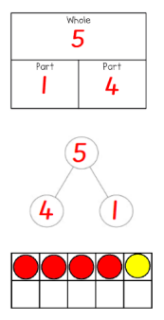 | Key Vocabulary  add  plus  equals  altogether  part  whole
The aim is for them to know several pairs of numbers that make the totals 1 to 5.

Top Tips
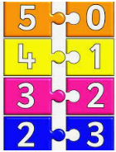
The secret to success is practising little and often. Use time wisely. Can you practise these KIRFs while walking to school or during a car journey? Maybe focus on one number a day. How many ways can we make the number?
Number bonds/pairs are two numbers that always go together to make a target number. So for example, number bonds to 5 are as follows:
Use a coat hanger and pegs to show the number bonds. How many different ways can you make five? What ways could you record your answers? Building confidence in mathematics is crucial so be pleased with your child’s efforts and always encourage with praise. Make sure these practice sessions are enjoyable - if your child is really not in the mood it is the wrong time to be practising!

