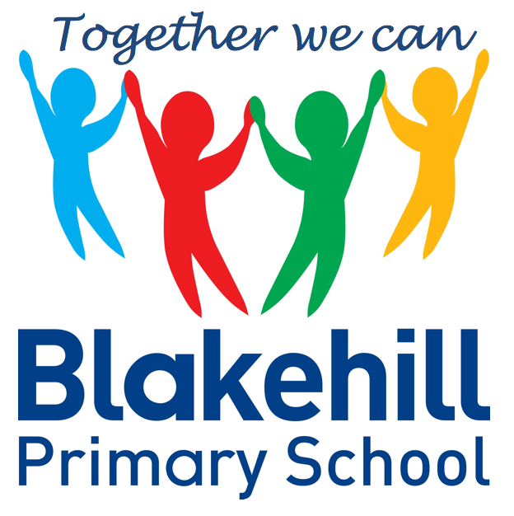
English
- The children will be reading stories with familiar settings by Mini Grey. They will be writing their own stories about the characters in these books.
- The children will be writing a report about Saltaire and about their visit there.

- History Study of Saltaire looking at homes and jobs and studying the life of Titus Salt. There will be a visit to Saltaire- details to follow.
- Geography We will be studying Saltaire. We will use geographical language to describe human and physical features of the location.
- Art We will be studying the work of artist David Hockney. The children will be doing observational drawings of buildings in Saltaire.
- Design and Technology Design and make a model of a wheeled toy. We will be learning about wheels and axels.
- Science- We will be looking at the uses of everyday materials.

Science, History, Geography, Art and D&T
- PSHCE Learning about safety in the home
- RE Myself- Reflecting on what is special about me and my name. We will also be finding out about the Jewish New Year.

- Outdoor athletics
- Indoor gymnastics
Please ensure your child has their PE kits in school on the relevant days, and that it is all named.

- Media
- Computing Science
- E –Safety

- Maths: Quick recall maths facts will be sent home to learn for a weekly test.
- Spellings: Spellings will be tested on a weekly basis.
- Reading: Read with your child as often as possible. Children will be encouraged to change their reading books every day.
Please ensure that your child has a water bottle every day filled with water only please.
Any money sent into school should be in a named envelope. Thank you.

Other information
- How does music help us to make friends? We will be learning about Gospel, 20th Century Orchestral, Jazz, Rock and Pop music.

Half Term Curriculum Overview

- Number and place value- count and represent numbers to 100, compare and order numbers, count in 2s, 5s, 10s and 3s
- Addition and Subtraction
- Consolidation
- Practising KIRFs
- Learning 2, 5 and 10 times tables

Mathematics
PSHCE and RE
Physical Education
ICT
Music
Year 2 Autumn 1 2021

