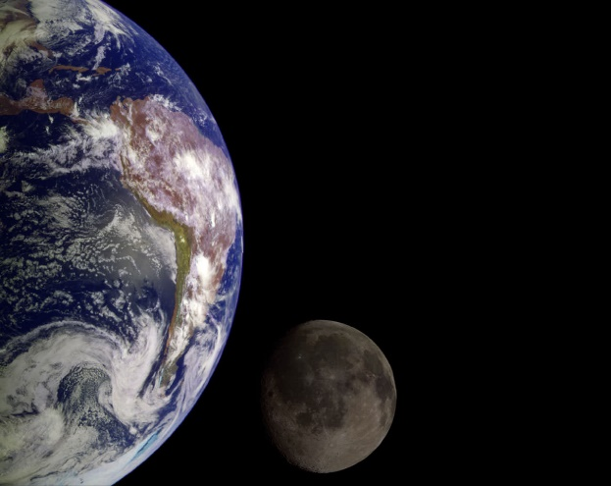

**Y5: Earth and space (Earth and space)**

Earth, Sun, Moon, (Mercury, Jupiter, Saturn, Venus, Mars, Uranus, Neptune), spherical, solar system, rotates, star, orbit, planets

Any other words:

**Science Vocabulary**

**Earth and space**

