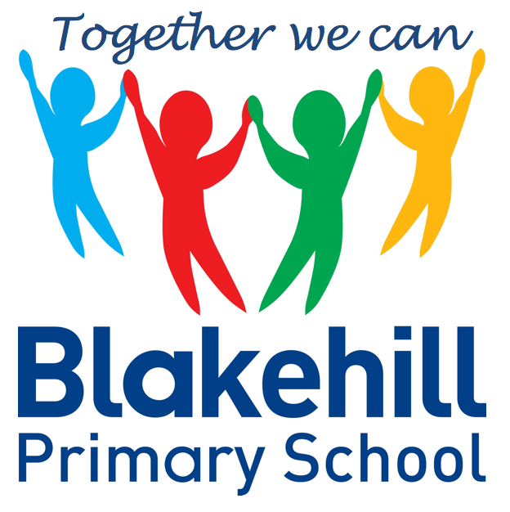
Personal, Social & Emotional
Children will be taking part in weekly circle times. They will have the opportunity to talk about themselves and their family. Children will be encouraged to take turns and listen to each other. We will also be talking about our wider school family, our school Golden Rules, good manners and how to be a good friend. We will continue to work on personal hygiene, such as regular handwashing and looking after our teeth.

Reading and Writing
Most children this half-term will bring home a phonics based book to read. Please ensure your child keeps their reading record in their book bag. Children will be encouraged to use their phoneme fingers to sound out and blend words using their phonic knowledge. Please continue to share a book with your child every day if possible. In writing children will be again encouraged to use their phoneme fingers to sound out and write simple words and sentences using phonic knowledge and the tricky words learnt so far. They will also be taught to use finger spaces and full stops.
We will continue to practise daily name writing and correct letter formation and again it would help to practise this at home. Your child’s names should start with a capital letter, but the rest of the letters should be lower case. In writing we will also be encouraging children to use finger spaces.

This half term our topic will be ‘Living and Growing.’ We will be looking at similarities and differences in relation to living things and finding out how all living things grow. We will be growing our own plants, making observations of them and looking at how we need to show care and concern for living things and the environment. We will be carrying out a fieldwork study of our school environment, including a sensory trail and talking about features of our school grounds.
.

Understanding of
the World
We start each morning with yoga or Supermovers to get active and use ‘Dough Disco’ to work on our fine motor skills. There are daily opportunities for children to play outside and every Friday children will do PE with Mr Simmons, our PE coach. Please could we again ask that children practise putting on and fastening their coats independently at home.

This half term we will continue to work through the Phase 3 sounds and tricky words. We will revisit all the sounds taught so far and there will be a catch up programme for the children who are not yet confident with Phase 2 sounds. Children should now be beginning to blend sounds together to make words and should be able to recognise some tricky words on sight.

Children will have the chance to work creatively every day in our areas of indoor and outdoor provision. There will be weekly music sessions with Mrs Brown. This half term children will again be singing familiar songs and nursery rhymes. They will also be exploring sounds and will have the opportunity to use different musical instruments.

Book Bags- Please remember that your child needs to bring their book bag to school every day.
Water bottles- Please make sure that your child has a clearly named water bottle in school every day and that this contains only water. Please don’t transport your water bottle in your book bag as the water can damage the reading books if they leak.
PE kit- At the current time your child just needs to come to school in their PE kit each Friday.
Rainbow Factory Visit – 27 April 2021 – Theme – Jack and the Beanstalk

Other information
Half Term Curriculum Overview

We will continue to have a daily maths session after lunch. Our topics for this half-term will be:

Growing 6,7,8 - Time – now, before, later, soon, after, then, next, yesterday, today, tomorrow, days of the week.
Building 9 and 10 - Counting, representating and subitizing 9 and 10. Use of 10 frames to explore composition. Comparing numbers to 10. Bonds to 10. 3D Shape. Pattern.
To 20 and Beyond - Consolidation of key skills: Subitising,
Counting, Composition, Sorting and Matching, Comparing and Ordering. Building numbers beyond 10. Counting patterns beyond 10. Spatial Reasoning: Match, rotate, manipulate

You can help your child at home by identifying and talking about numbers and shapes in the environment and by practising the formation of numbers.

Mathematics
Physical Development
Phonics
Expressive Art & Design
Reception Summer 1 Term 2021 – Fairy Tales

