To multiply and divide 1 and 2 digit numbers by 10 and 100.

By the end of this half term, children should know the following facts. The aim is for them to recall these facts instantly.
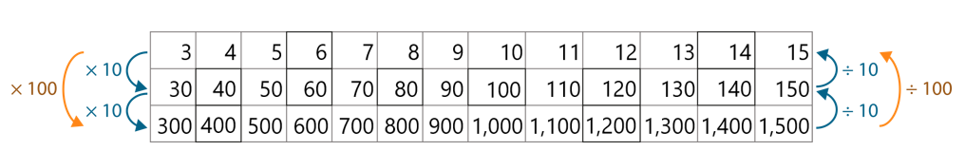
Children need to be able to visualise and understand making a number ten times bigger and that ‘ten times bigger’ is the same as multiplying by 10. They will build on multiplying by 10 and see links between multiplying by 10 and multiplying by 100.
They should begin to understand the relationship between multiplying and dividing by 10 and 100 as the inverse of the other.

Top Tips
The secret to success is practising little and often. Use time wisely. Can you practise these KIRFs while walking to school or during a car journey? You don’t need to practise them all at once: perhaps you could have a fact of the day.
Use memory tricks – For those hard-to-remember facts, create picture stories to help children to remember.
White Rose Maths – watch the videos to help you understand:

https://vimeo.com/474994166 Multiply by 10

https://vimeo.com/475113712 Divide by 10

https://vimeo.com/474994600 Multiply by 100

https://vimeo.com/475385464 Divide by 100

