**Updated September 2024**

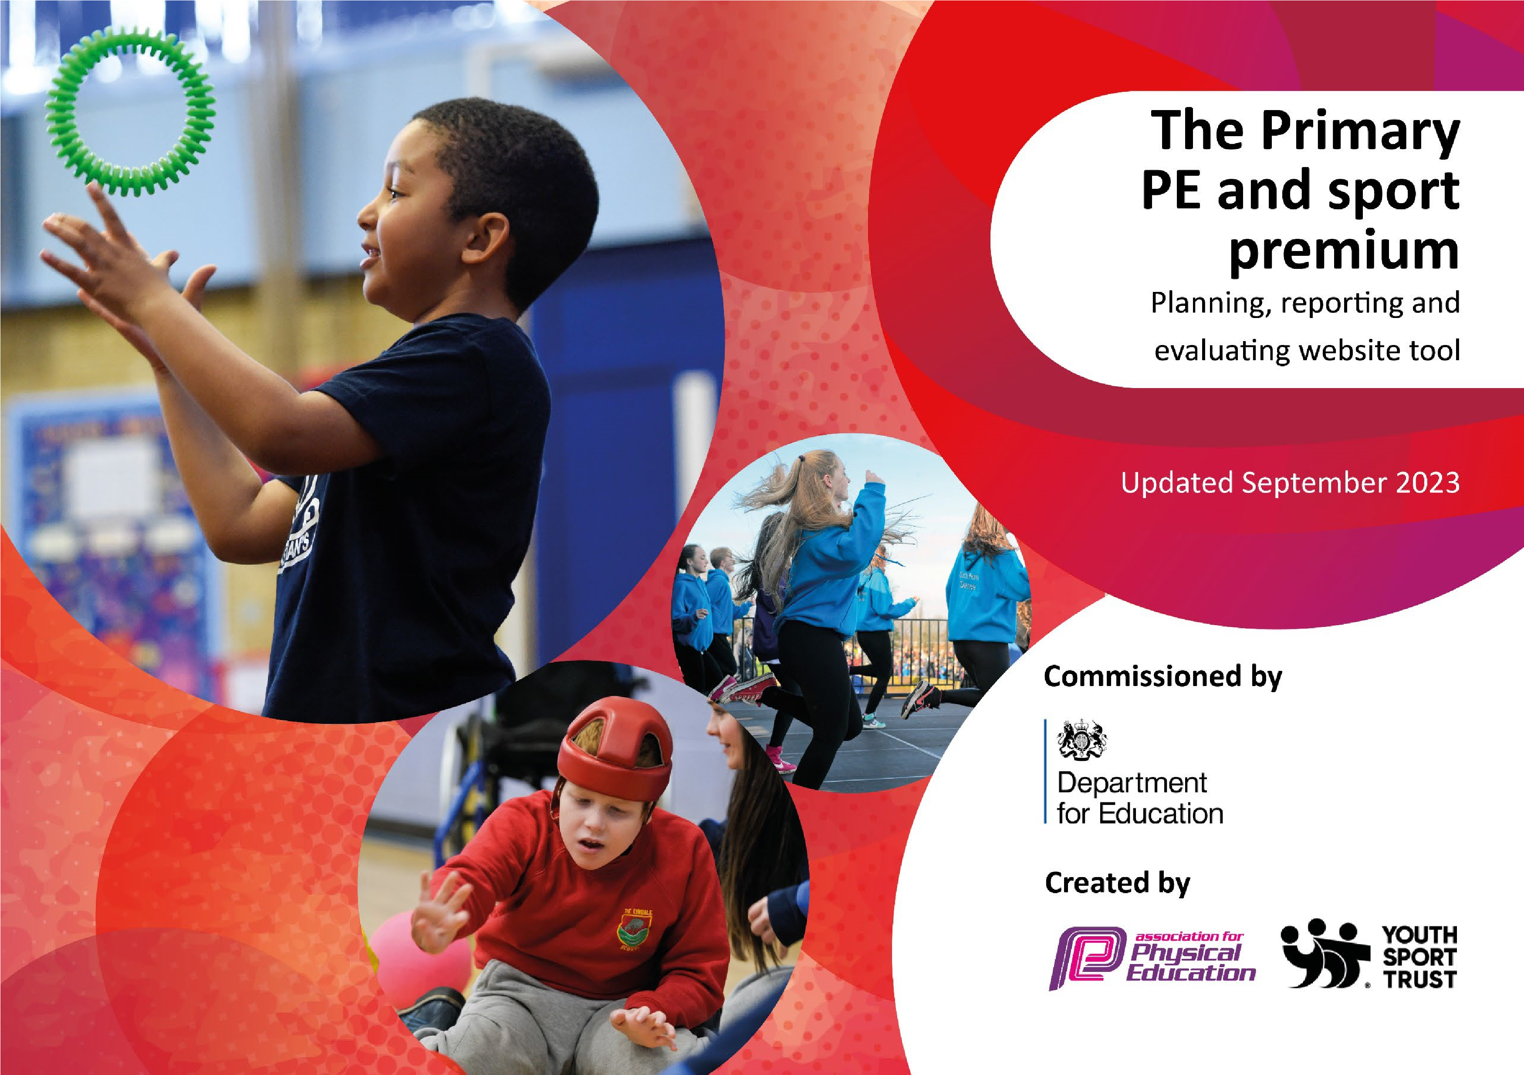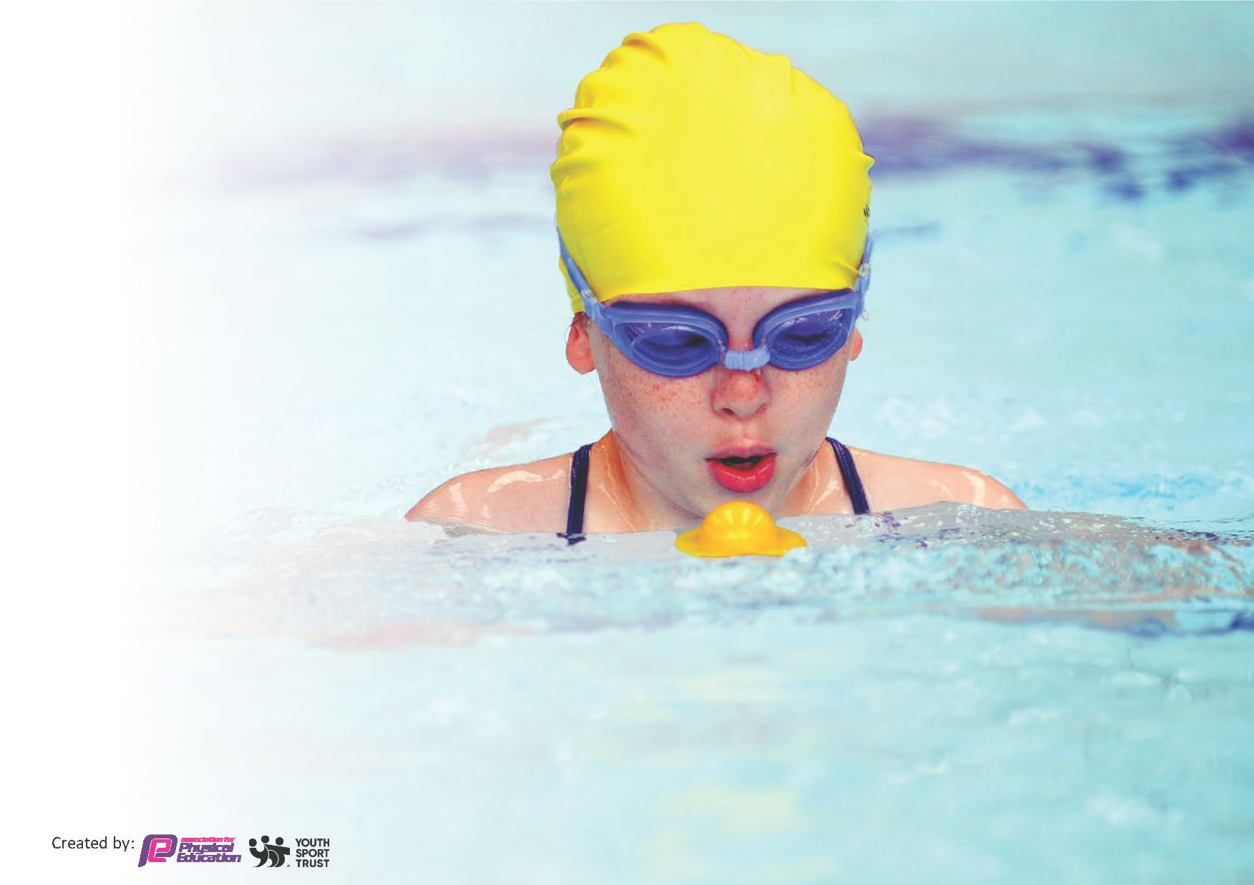

This template can be used for multiple purposes:

•

It enables schools to effectively plan their use of the

Primary PE and sport premium

•

It helps schools to meet the requirements (as set out

in guidance) to publish information on their Primary

PE and sport premium

•

It will be an effective document to support Ofsted

inspections enabling schools to evidence progress

in Physical Education (PE) and evidence swimming

attainment, which forms part of the PE National

Curriculum. We would recommend schools consider

the Intent, Implementation and Impact of any spend, as

examined within the Education Inspection Framework.

It is important that your grant is used effectively and based on

school need.

Schools must use the funding to

make

**additional and sustainable**

**improvements**

to the quality of the PE,

School Sport and Physical Activity (PESSPA)

they offer. This means that you should use the Primary PE and sport premium to:

•

Build capacity and capability within the school to ensure that improvements made now will benefit pupils joining the

school in future years

•

Develop or add to the PESSPA activities that your school already offers.

**The Primary PE and sport premium should not be used to fund capital spend projects; the school’s core budget should fund**

**these. Further detail on capital expenditure can be found in the updated**

[**Primary PE and sport premium guidanc**](https://www.gov.uk/guidance/pe-and-sport-premium-for-primary-schools)

[**e**](https://www.gov.uk/guidance/pe-and-sport-premium-for-primary-schools)

[**.**](https://www.gov.uk/guidance/pe-and-sport-premium-for-primary-schools)

The Primary PE and sport premium guidance, outlines 5 key priorities that funding should be used towards. It is not

necessary that spending has to meet all the key priorities, you should select the priorities that you aim to use any funding towards.

Although completing this template is not a requirement for schools, schools are required to publish details of how they spend this funding. Schools must also outline what the impact this funding has had on pupils’ PE and sport participation and attainment and how any spending will be sustainable in the future. **All funding must be spent by 31st July 2025.**

The Department for Education has worked closely with the Association for Physical Education (afPE) and the Youth Sport Trust (YST) to develop this template and encourages schools to use it. This template is an effective way of meeting the reporting requirements of the Primary PE and sport premium.

# Review of last year’s spend and key achievements (2023/2024) £19,540 allocated

We recommend you start by reflecting on the impact of current provision and reviewing your previous spend.

|  |  |  |
| --- | --- | --- |
| **Activity/Action** | **Impact** | **Comments** |
| 1. A Sports and Personal Development Officer was appointed in 2022 with the central aim of increasing participation and opportunity in sport and personal development activities for all children.   This is part funded via Sports Premium / Pupil Premium Funding  £13,500 | 226 pupils attended at least one after school club 2023/24  77 before / after school clubs delivered during 2023/24  More pupils are actively more involved in sport and personal development opportunities  All pupils have the chance to take part in sport  All sections of the school community are aware of available activities and where they can go to get involved.  Information is distributed via social media, letters etc about sport-related projects, classes, programmes, coaching, club development and training maintaining a high profile.  Pupils are identified for participation from a range of different criteria ( e.g. for fun, those interested in competing at all levels, from local to national and international.)  Success for individual / team competitors  The delivery of the existing PE Curriculum in school is supported by the SPDO and he works with colleagues to maintain the high quality of education.  . | A wide range of children, especially from disadvantaged backgrounds, have accessed our after-school clubs.  The visibility and profile of PE at Blakehill is acknowledged across the district with many children excelling in sport  100% of parents agree that the school provides a broad and rich curriculum and a range of extra- curricular activities |
| 1. To increase the number and range of sporting activities and events available for all children across the school including at local and national level   (£3,600)   * Sports UK competition package and planning documents (£2200) * Transport costs to / from events/festivals/competitions: £600 * School costs – organising and hosting events £200 * Purchase of balance bikes £400 * Health Week activities / resources: £400 | Inter school cross country events organised and hosted by SPDO 3x annually £200  Participation in local and national competitions and events secure success eg. u11 Road to Wembley / Blackpool Cup  School recognised locally as a sporting success  Teams / individual success at events Full and increased timetable of extra-curricular activities provided (17 before / after school clubs termly) meaning all pupils have access to activities  Lunchtime clubs/ provision provided – increase engagement/ activity  Balance bikes purchased and training provided for Reception / KS1 pupils £400  Whole school Health week activities combine health, sport, science and nutrition providing a balanced health education to the while school  Festival and competition package for inter school events organised by Sports UK increased opportunity and participation offer  Schools Games Programme – Hanson Academy | Children enjoy their outdoor time in Year 1 due to the increased variety of activities available. This means that children are able to stay on task for longer therefore increasing their active time, physical development and stamina.    Local and national media coverage in recognition of U11 boys football achievements  Competition fees |
| 1. Purchase more playtime, lunchtime and PE resources and equipment     (£1,000) | The outdoor area in KS2 has been developed providing designated areas for children to play. Additional play equipment purchased  Playtimes and lunchtimes are now much more structured  There are a variety of sports and activities available to the children to ensure that playtimes encourage children to be active as much as possible.  There has been a decrease in behaviour incidents at lunchtime since the start of the year (evidence on CPOMs) due to the structure and activities on offer during play. | From pupil surveys, the vast majority of children (over 94%) consistently enjoy playtimes and lunchtimes.  Different sports / activities are available for children to access. |
| 1. Provide staff with access to high quality CPD and planning to support them in their delivery of the PE curriculum   £1500 | PE Planning (Sports UK) provides detailed and comprehensive planning (costed above)  Designated Sports Coach and SDPO provides regular and expert CPD to staff annually £250  SDPO delivers Commando Joe SEL activities to pupils across KS2 – programme purchased 2023 and part funded (SP/PP) increased pupil self- regulation and active participation opportunities £1000  Release / supply time for PE leader £250 to meet with PE team – development priorities ensures leaders have a clear vision for Sport and PE at Blakehill | Expert on hand to support with PE, lunchtime provision and extra curricular activities.  Three members of staff dedicated to the leadership and management of PE and our sport offer:  PE Leader: Mr Sugden  Sports and Personal Development Officer: Mr Lumb  Sports Coach: Mr Hargreaves |
| Development of Play leaders and buddies support the play and interaction of their peers and younger pupils  – Y5 and Y6 pupils to receive training.  No cost – time of SDPO / Learning Mentor and Pastoral support | Children have received training on how to be a play leader. They have supported the running of play and lunchtimes, improving the activities and opportunities for the other children and supporting play.    Increased visibility of ‘ buddies’ across school  Increased responsibilities of our eldest pupils | . |

Total spend: £19,600

|  |  |
| --- | --- |
| **Key priorities and Planning (2024/2025)** | **Grant Amount: £19,540 Total Spend: £20,730 (£1,190 Overspend)** |

This planning template will allow schools to accurately plan their spending.

|  |  |  |  |  |
| --- | --- | --- | --- | --- |
| **Action – what are you planning to do** | **Who does**  **this action impact?** | **Key indicator to meet** | **Impacts and how sustainability will be achieved?** | **Cost linked to the action** |
| Continue to develop our PE curriculum through the use of Sports UK planning | Teaching staff and pupils | Key Indicator 1  Key Indicator 2 | All teaching staff and Sports Coach and HLTAs to have access to Sports UK planning and competition/ festival access    To continue to develop the confidence and knowledge of all our teaching staff to deliver high-quality PE sessions.    Further CPD from our Sports Coach and PE lead to ensure staff are supported using Sports UK planning | £2,200    (Sports Premium). |
| Purchase further resources and equipment to support PE sessions and playtime/lunchtime | Teaching staff and pupils | Key Indicator 2  Key Indicator 4 | Training and support in place for the use of the new sports equipment.  Clear systems and routines in place for the distribution and storage of equipment.  Continue to provide a wide range of activities and structured play for all our children during playtimes, lunchtimes and PE sessions. | £1,000    (Sports Premium) |
| Dedicated time for our Sports Coach / Sports and Personal Development Officer and other school staff to run extra-curricular activities including after school clubs.  Dedicated time for our  Sports and Personal Development Officer and a member of the pastoral team to run Commando Joe sessions. | Pupils  Pupils | Key Indicator 2  Key Indicator 3  Key Indicator 4  Key Indicator 5 | We aim to continue to offer a wide range of extra-curricular activities and opportunities to all children across school, with a particular focus on our disadvantaged children. Clubs will run throughout the week and will include a variety of sports clubs. We will ensure we cover and release teachers and support staff who are interested in running a  club to ensure the sustainability going forward of clubs and ensuring that a wide range if people are involved.  Commando Joe will become a key part of our curriculum. This is led in school by our Sports and Personal Development Officer Coach. He will lead sessions but also team teach with class teachers to improve the confidence of teachers and support staff when using the programme. This will ensure the sustainability of the programme going forward. | £13,500 + SDPO  £2730 (PE Coach)  Applies to below action also) (Sports Premium and Pupil Premium funding  Clubs are paid for by parents and funded by school where required |
| Increase opportunities for pupils with SEND to participate in sport/ sporting events | Pupils with SEND |  | Festivals and events will be organised and hosted by the school’s sports and personal development officer in liaison with the PE Leader for pupils with SEND.  This offer will accommodate pupils from schools across the district and culminate in half termly ‘Inclusion Games’ events | Purchase of resources.  Dedicated time for SDPO and other staff  £1000 |

|  |  |  |  |  |
| --- | --- | --- | --- | --- |
| Continue to Increase the number of competitions and events ( inter, intra and regional /national that we attend as a school | Teaching staff, pupils and  families | Key Indicator 3  Key Indicator 4  Key Indicator 5 | Increase in the number of inter-school competitions. These will be led by our Sports Coach/ SDPO  Continue to ensure Blakehill Festivals continue to be high profile | £600  Transport costs |
| Ensure our children access a wide range of outdoor and active experiences | Pupils and families | Key Indicator 2  Key Indicator 3  Key Indicator 4 | Visits, residentials and experiences are an integral part of the Personal Development offer at Blakehill Primary.  Forest schools provide opportunities both in school time and extra curricular for outdoor learning experiences | Paid events – school support with payment where required ef forest schools  £300 |

# Key Swimming Data

*Meeting National Curriculum requirements for swimming and water safety.*

*Priority should always be given to ensuring that pupils can perform safe self-rescue even if they do not fully meet the first two requirements of the National Curriculum programme of study*

|  |  |  |
| --- | --- | --- |
| **Question** | **Stats:** | **Further context**  **Relative to local challenges** |
| What percentage of your current  Year 6 cohort can swim competently, confidently and proficiently over a distance of at least 25 metres? | 80% | This cohort of children went swimming in Y4, at which time we could send classes of 30 with a ratio of instructors: swimmers of 1:15. This data is the outcomes of the swimming lessons at the end of Y4. No further data is available on pupils who may now be able to swim proficiently as no further lessons were possible. Pupils may have taken lessons outside of school and therefore may now be proficient in swimming. |
| What percentage of your current Year 6 cohort can use a range of strokes effectively [for example, front crawl, backstroke, and breaststroke]? | 54% | This cohort of children went swimming in Y4, at which time we could send classes of 30 with a ratio of instructors: swimmers of 1:15. This data is the outcomes of the swimming lessons at the end of Y4. No further data is available on pupils who may now be able to swim proficiently as no further lessons were possible lessons were possible due to a lack of available swimming provision. These pupils may have taken lessons outside of school and therefore may now be proficient in swimming. |
| What percentage of your current Year 6 cohort are able to perform safe self-rescue in different water-based situations? | 54% | This cohort of children went swimming in Year 4, at which time we could send classes of 30 with a ratio of instructors: swimmers of 1:15. This data is the outcomes of the swimming lessons at the end of Y4. No further data is available on pupils who may now be able to swim proficiently as no further lessons were possible lessons were possible due to a lack of available swimming provision. These pupils may have taken lessons outside of school and therefore may now be proficient in swimming. |
| If your schools swimming data is below national expectation, you can choose to use the Primary PE and sport premium to provide additional top-up sessions for those pupils that did not meet National  Curriculum requirements after the completion of core lessons.  Have you done this? | No | Not below national. |
| Have you provided CPD to improve the knowledge and confidence of staff to be able to teach swimming and water safety? | No | Swimming lessons are provided by the local authority and their swimming instructors. |

Signed off by:

|  |  |
| --- | --- |
| Head Teacher: | Lisa Keighley |
| Subject Leader or the individual responsible for the Primary PE and sport premium: | James Sugden  Mathew Lumb SPDO |
| Governor: | Curriculum Committee |
| Date: | September 2024 |