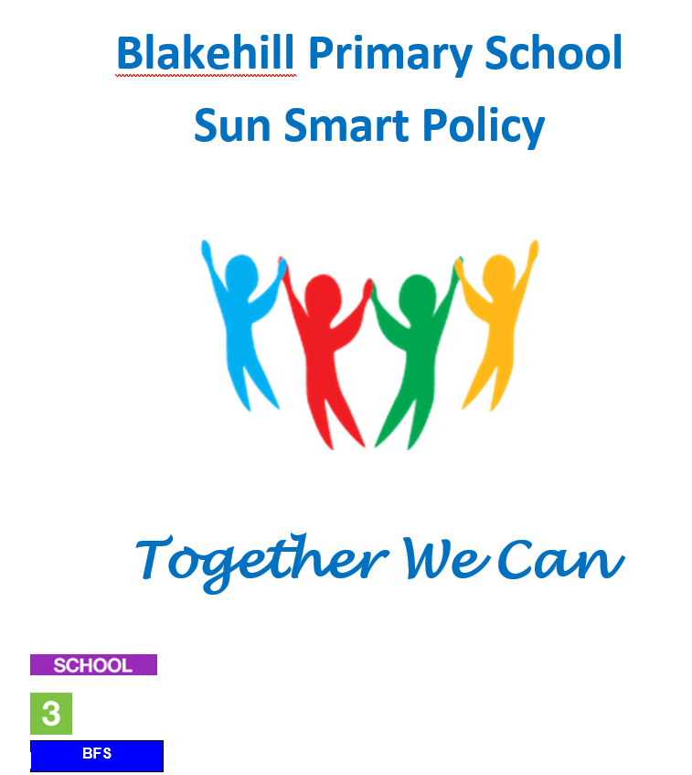
Headteacher | Chair of Governors | Review Dates
 |  | Last Review: October 2026
Lisa Keighley | Hayley Dyson | Next Review: October 2027

Blakehill Primary School Sun Smart Policy
This policy applies to all events on and off-site.

Rationale

Too much of the sun’s UV radiation can cause sunburn, skin and eye damage and skin cancer. Infants and toddlers up to four years of age are particularly vulnerable to UV damage due to lower levels of melanin and a thinner stratum corneum (the outermost layer of skin). UV damage accumulated during childhood and adolescence is strongly associated with an increased risk of skin cancer later in life

Purpose
This SunSmart policy provides guidelines to:
- ensure all children, and staff are protected from over-exposure to UV radiation;
- ensure the outdoor environment provides shade for children, educators and staff;
- ensure children are encouraged and supported to develop independent sun protection skills;

Procedures
It is the role of senior leaders in the school to ensure that they:

Seek shade
- make sure there is a sufficient number of shelters and trees providing shade in the outdoor area particularly in high-use areas.
- The availability of shade is considered when planning all outdoor activities.
- Children are encouraged to choose and use available areas of shade when outside to minimise any over exposure to sunlight for longer periods of outdoor play/ activities
- Children who do not have appropriate hats or outdoor clothing are asked to choose a shady play space or a suitable area protected from the sun.

To support this:
- We have a canopy outside reception area.
We have seated area providing natural shade from a tree next to the school field.
We have a shelter and seating next to the Years 5/6 entrance on the top playground.
- Sports days timetabled at either in the morning or late afternoon in order to avoid when sun is most intense depending on heat/ sun intensity. Decision to postpone will be made according to temperatures/forecast
Pupils will not have PE after lunch if deemed unsafe by teacher.
Breaktimes are not to be extended to reduce over exposure.
- Outdoor lunchtime play where there is limited access to shade/increased heat exposure may be shortened.
Slap on sun-protective clothing
- Children advised to wear loose-fitting clothing that covers as much skin as possible during periods of intense heat/ sun exposure
- Children are advised to wear hats that protect their face, neck

To support this we:
- Encourage pupils to wear clothing that is sun smart
Encourage pupils to wear t-shirt for PE
Encouraged staff to be good role models and wear hats and sunglasses when on break duty and PE.

3 Slop on sunscreen
- SPF15 (or higher) broad-spectrum, water-resistant sunscreen is recommended to parents.
- Sunscreen is applied in accordance with the manufacturer’s directions (applied at least 20 minutes before going outdoors and reapplied every two hours, or more frequently if sweating or swimming).
- To help develop independent skills ready for school, children should apply their own sunscreen under supervision of staff, and are encouraged to do so.
- Sunscreen is stored in a cool place, out of the sun

To support this:
Parents are asked to put factor 15+ on their child before they come to school.
Parents are reminded that on educational visit correspondence that pupils should have appropriate sunscreen applied (factor 15+) and that suitable clothing should be worn.
- Implement a programme of education

Sun protection education is incorporated into the curriculum
The SunSmart policy is reinforced by staff and through children's activities and displays.
Pupils, staff and families are provided with information about sun protection through family newsletters, school prospectus, display boards and signposting to services

To support this:
Deliver sun smart assemblies
Teach about being safe in the sun/ hot weather
Ensure the Sun Smart policy is available to parents and visitors

Monitoring and review
All staff, including SLT, monitor and review the effectiveness of the SunSmart policy and revise the policy when required (at least once every three years) by completing a policy review.

