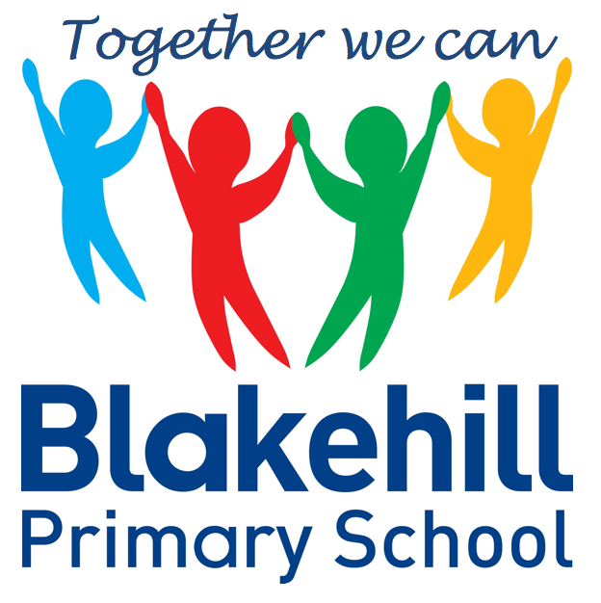
English
- Writing about ourselves and families
- ‘Is a worry worrying you?’ We will be talking and writing about worries we may have about being back at school
- Information writing about Saltaire and writing about our visit

- History Study of Saltaire looking at homes and jobs and studying the life of Titus Salt. There will be a visit to Saltaire- details to follow.
- Geography We will be studying Saltaire. We will use geographical language to describe human and physical features of the location.
- Art We will be studying the work of artist David Hockney. The children will be doing observational drawings of buildings in Saltaire.
- Design and Technology Design and make a model of a Saltaire house or a playground in Saltaire.
- Science- We will be looking at the uses of everyday materials.

Science, History, Geography, Art and D&T
- PSHCE Myself- recognising positive things about myself
- RE Myself- Reflecting on what is special about me and my name.

- Outdoor athletics
- Indoor gymnastics
Please ensure your child has their PE kits in school on the relevant days, and that it is all named.

- Computing
- E –Safety

- Maths: ‘KIRFS’ will be sent home to learn for a weekly test.
- Spellings: Word Mountains will be tested on a weekly basis.
- Reading: Read with your child as often as possible. A set of books for your child to take home will be changed every week.
Please ensure that your child has a water bottle every day filled with water only please.
Any money sent into school should be in a named envelope. Thank you.

Other information
- The children will be learning to sing a South African song called ‘Hands, Feet and Heart.
Half Term Curriculum Overview

- Revision of Year 1 work
- Number and place value- count and represent numbers to 100, compare and order numbers, count in 2s, 5s, 10s and 3s
- Addition and Subtraction
- Consolidation
- Practising KIRFS

Mathematics
PSHCE and RE
Physical Education
ICT
Music
Year 2 Autumn 1 2020

