**Y5: Materials (materials)**

Thermal/electrical insulator/conductor, change of state, mixture, dissolve, solution, soluble, insoluble, filter, sieve, reversible/non-reversible change, burning, rusting, new material, sediment

**Y4: Changes of state (materials)**

Solid, liquid, gas, state change, melting, freezing, melting point, boiling point, evaporation, temperature, water cycle

**Year 2: Changing shape / use of materials (materials)**

opaque, transparent, translucent, reflective, non-reflective, flexible, rigid

Shape, push/pushing, pull/puling, twist/twisting, squash/squashing, bend/bending, stretch/stretching

**Year 1: Identifying / comparing materials (materials)**

Object, material, wood, plastic, glass, metal, water, rock, brick, paper, fabric, elastic, foil, card/cardboard, rubber, wool, clay

hard, soft, stretchy, stiff, bendy, floppy, waterproof, absorbent, breaks/tears, rough, smooth, shiny, dull, see-through, not see-through

**Science Vocabulary**

**Materials**

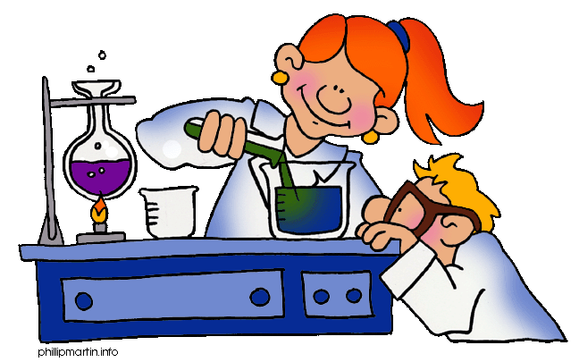

**Y5: separating mixtures (materials)**

Thermal/electrical insulator/conductor, change of state, mixture, dissolve, solution, soluble, insoluble, filter, sieve, reversible/non-reversible change, burning, rusting, new material

**Y5: Types of change (materials)**

Thermal/electrical insulator/conductor, change of state, mixture, dissolve, solution, soluble, insoluble, filter, sieve, reversible/non-reversible change, burning, rusting, new material

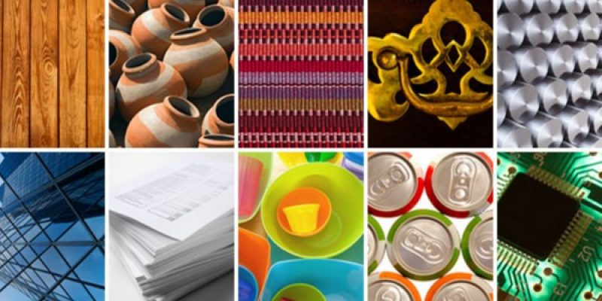

**Any other words:**