To multiply and divide 1 digit numbers by 10.

By the end of this half term, children should know the following facts. The aim is for them to recall these facts instantly.
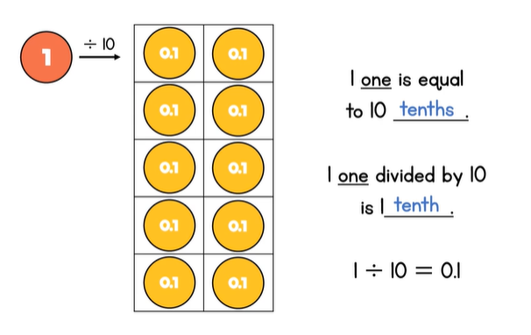 | 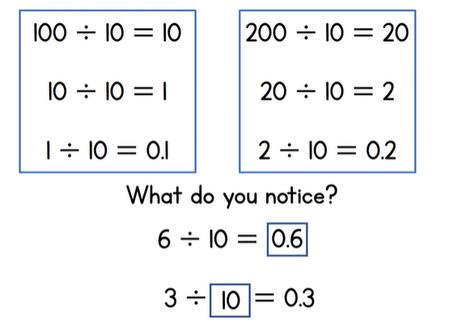

Top Tips
The secret to success is practising little and often. Use time wisely. Can you practise these KIRFs while walking to school or during a car journey? You don’t need to practise them all at once: perhaps you could have a fact of the day.
Use memory tricks – For those hard-to-remember facts, create picture stories to help children to remember.
White Rose Maths – watch the video to help you understand:

https://vimeo.com/399086274

