Year 4: Sound UPDATED November 2023
Links made with other subjects | Computing media – producing and editing sounds
The BIG Question | How do we hear different sounds?
The BIG Outcome | Children to demonstrate the knowledge they have learnt during this unit to create a diagram and accompanying explanation answering the BIG question.
Science objectives  (link to NC) | - Identify how sounds are made, associating some of them with something vibrating.  - Recognise that vibrations from sounds travel through a medium to the ear.  - Find patterns between the pitch of a sound and features of the object that produced it.  - Find patterns between the volume of a sound and the strength of the vibrations that produced it.  - Recognise that sounds get fainter as the distance from the sound source increases.
Prior knowledge  What prior knowledge is needed for children to be successful in this unit? | Children already know:  EYFS – Understanding the world. Children know about similarities and differences in relation to places, objects, materials and living things. They can talk about the features of their own immediate environment and how environments might vary from one another. They can make observations of animals and plants and explain why some things occur. They can talk about changes.  Yr 1: Senses Animals Including Humans
Future learning  Consider the conceptual knowledge within a subject that pupils need for future learning not just the recall of facts but the importance of concepts | This unit gives prior knowledge to:  Key Stage 3:  - Waves on water as undulations which travel through water with transverse motion; these waves can be reflected, and add or cancel creating superposition.  - Frequencies of sound waves, measured in Hertz (Hz); echoes, reflection and absorption of sound.  - Sound needs a medium to travel, the speed of sound in air, in water, in solids.  - Sound produced by vibrations of objects, in loud speakers, detected by their effects on microphone diaphragm and the ear drum; sound waves are longitudinal.  - Auditory range of humans and animals.  - Pressure waves transferring energy; use for cleaning and physiotherapy by ultra-sound.  - Waves transferring information for conversion to electrical signals by microphone.
Science strands | Related Enquiry Questions  Classifying  -Based on the children’s own criteria, sort musical instruments.  Observing over time  Not relevant  Pattern Seeking  Not relevant  Comparative testing  - Measure volume from different instruments.  - Measure how volume changes away from a source.  - Investigate string telephones.  - Explore pitch e.g. through a carousel of activities using milk bottles, straw pipes, rulers, elastic band guitars.  Researching  - Research, make and play their own instruments based on what they learned about pitch and volume.
Vocabulary/ Glossary | Sound, source, vibrate, vibration, travel, pitch (high, low), volume, faint, loud, insulation
Knowledge  (see italics for knowledge to remember) | The knowledge that children will learn and remember:  - A sound produces vibrations which travel through a medium from the source to our ears.  - Different mediums such as solids, liquids and gases can carry sound, but sound cannot travel through a vacuum (an area empty of matter).  - The vibrations cause parts of our body inside our ears to vibrate, allowing us to hear (sense) the sound.  - To know some parts of the ear involved in the process: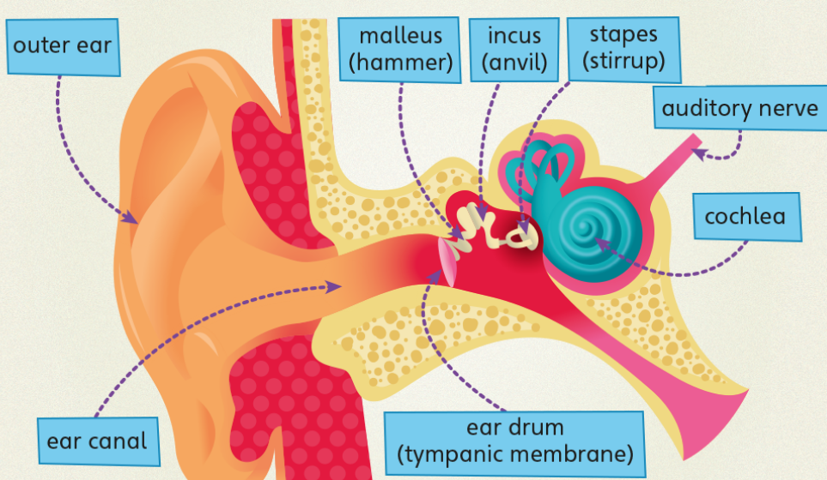  - The loudness (volume) of the sound depends on the strength (size) of vibrations which decreases as they travel through the medium.  - Sounds decrease in volume as you move away from the source.  - A sound insulator is a material which blocks sound effectively.  - Pitch is the highness or lowness of a sound and is affected by features of objects producing the sounds. For example, smaller objects usually produce higher pitched sounds e.g. 2 tighter strings produce higher pitched sounds
SEND expectations | - A sound produces vibrations which travel through a medium from the source to our ears.  - The vibrations cause parts of our body inside our ears to vibrate, allowing us to hear (sense) the sound.  - To know some parts of the ear involved in the process:  - The loudness (volume) of the sound depends on the strength (size) of vibrations which decreases as they travel through the medium.  - Sounds decrease in volume as you move away from the source.  - A sound insulator is a material which blocks sound effectively.  - Pitch is the highness or lowness of a sound and is affected by features of objects producing the sounds. For example, smaller objects usually produce higher pitched sounds.
Common misconceptions | Some children may think:  -sound is only heard by the listener  -sound only travels in one direction from the source  -sound can’t travel through solids and liquids  -high sounds are load and low sounds are quiet  -pitch and volume are frequently confused, as both can be described as high or low.

