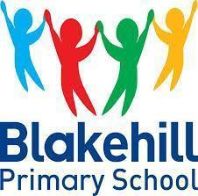

Classroom Environment Expectations
The classroom environment encompasses all factors that influence the quality of teaching and learning, including physical space, relationships, and the social and cultural context. It's not just about the physical classroom, but also the interactions, routines, and resources that shape student learning. Classroom environments at Blakehill are interactive and supportive, promoting high engagement and a positive learning experience for pupils, that support academic progress and foster student well-being.

Classroom Door
- Class Name
- Photograph of the staff
- Photograph of class councillor

Classroom
- School Rules
- Talk Rules and talk structures
- Zones of Regulation and toolkit
- Phonics poster (all year groups) and phoneme freeze (EYFS)
- Labelled medical bag location
- Behaviour Prompts
- Paper register complete
- Number of children present on board in template provided
- Visual timetable
- Working walls for English, Maths and Topic (Year 1 - Year 6)
- Working walls for Maths and phonics (EYFS).
- Celebration of pupils’ work on other displays
- Boxes of pupil books and trays clearly labelled
- Writing equipment, phonics mat and resources readily available on tables
- Tops of cupboards and surfaces clutter-free
- Groupings of tables meet the needs of the class
- Home tray next to the door

English Working Wall

- The working wall has a clear text/title and a picture of the current text being used as a stimulus.
- On the left-hand side is a list of key vocabulary that will be used throughout the unit of work.
- Work and key objectives will be added to the board moving from left to right, where possible, as you work through the unit of work.
- This may include prediction activities, SPaG examples, sentence structures, WAGOLLs, examples of key features of the text, children’s photocopied work, post-it ideas, group tasks or modelled examples by the teacher.
- Hessian coloured paper background to be used.

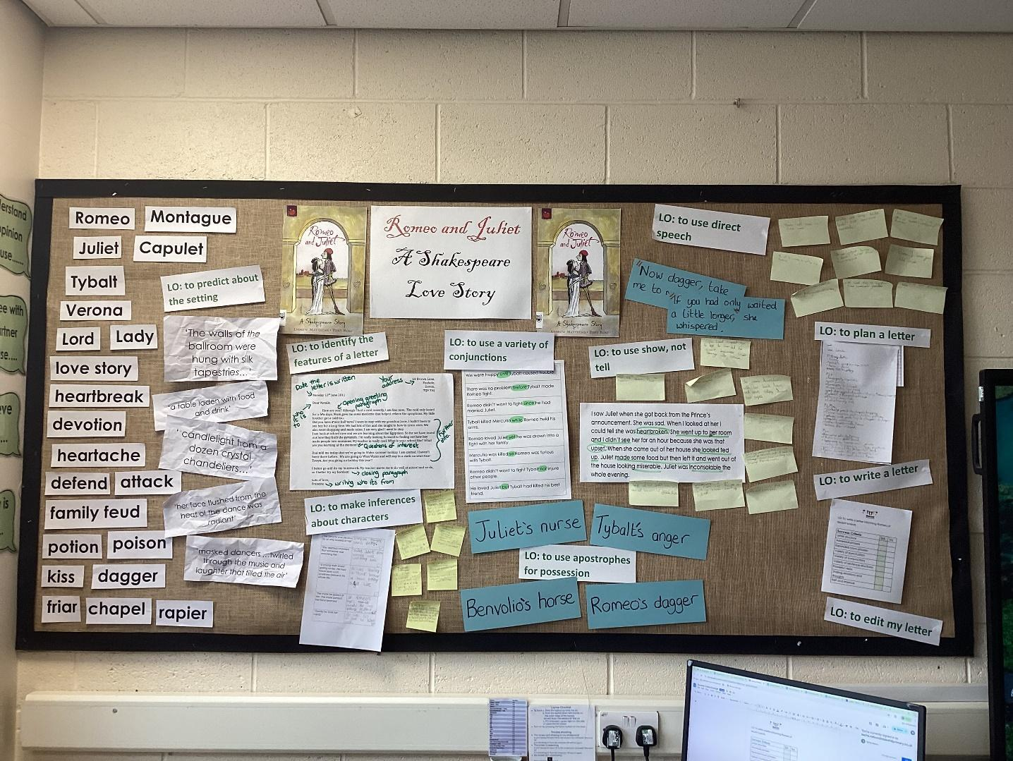
Maths Working Wall

- The working wall has a clear unit title e.g. Shape, Measure, Place Value
- On the left-hand side is a list of key vocabulary that will be used throughout the unit of work.
- Work will be added to the board moving from left to right, where appropriate, as you work through the unit of work.
- Children’s photocopied work, key facts, post-it ideas, group tasks or modelled examples by the teacher may be evidenced here.
- In KS2, there will be a clear example of the four calculations (age related expectations) on square paper visible for all to see, next to the board.
- In KS1, the calculations will be represented pictorially using appropriate resources (Base Ten/counters) including a drawing, as set out in the calculations policy.
- In Years 1 -4, a number square will be positioned near to the working wall. - turn numbers over re: timestables
- Year 1 -6 will display a place value grid (age appropriate) above their working wall.
- In EYFS, a large number track (1-30) will be positioned appropriately.
- In Year 1, a large number track (1-100) will be positioned appropriately.
- In Year 2, a large number track (0-110) will be positioned appropriately.
- Maths equipment needs to be clearly labelled and easily accessible to pupils.
- All Maths working walls are to be backed with squared paper from year 1.
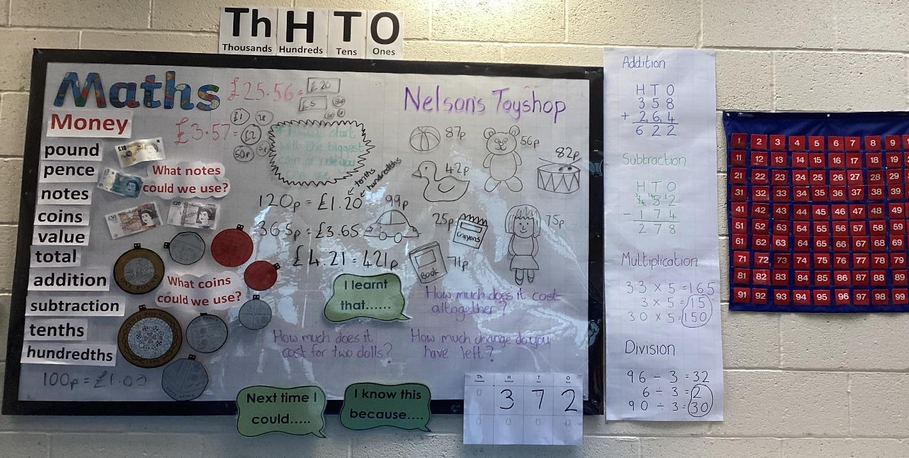

Topic Working Wall

- The working wall has a clear subject and title e.g. History - Ancient Egypt, Science - Plants.
- On the left-hand side is a list of key vocabulary that will be used throughout the unit of work.
- Work and key objectives will be added to the board moving from left to right as you work through the unit of work.
- Children’s photocopied work, post-it ideas, questions to foster curiosity, group tasks or modelled examples by the teacher may be evidenced here.
- Hessian/neutral backing to be used.

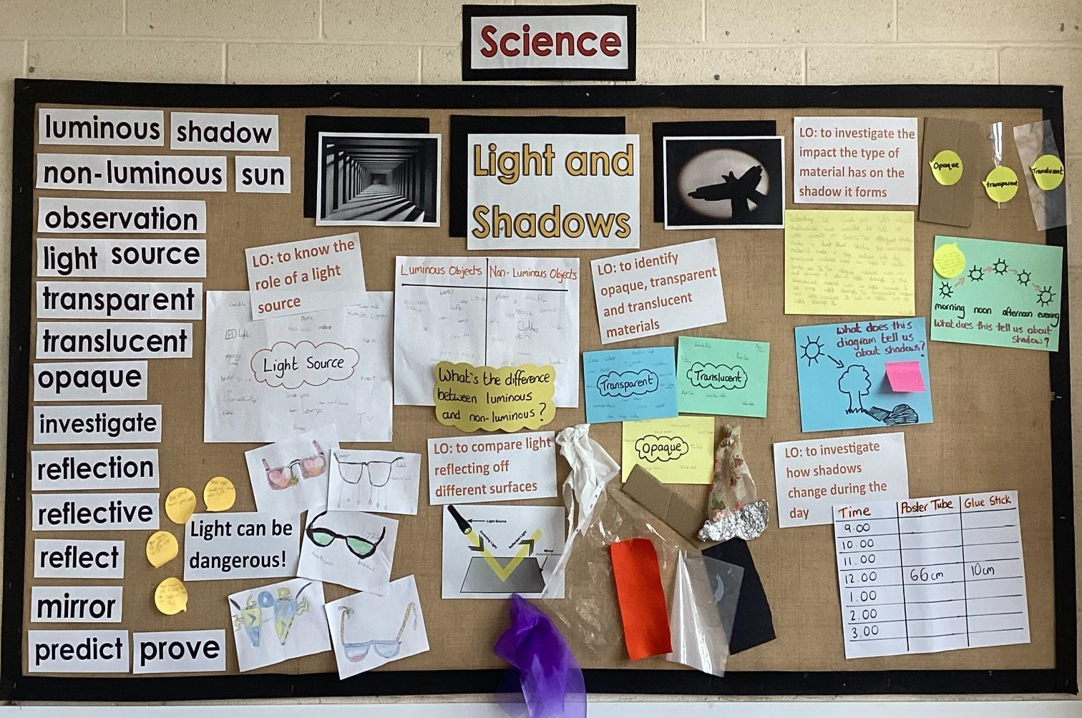

Working Wall Expectations
- All text on working walls is large enough for children to see from their seats.
- Working walls are uncluttered and plain in design in order to maintain clarity.
- Working walls are built up as the unit of work progresses.
- Working walls provide prompts for pupils and provide a pictorial representation of the learning that is taking place. They are not displays.
- Working walls are referred to in the course of the teaching sequence.
- Working walls are up to date and always reflect the unit of work that is currently being taught.
- Working walls are low in stimulus with neutral colours.
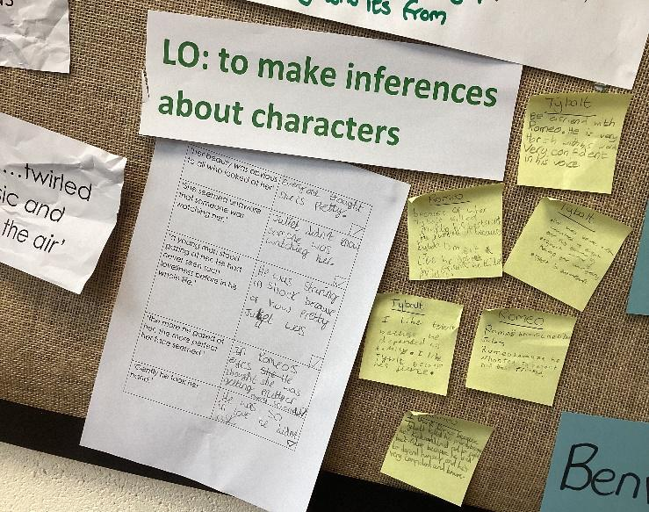
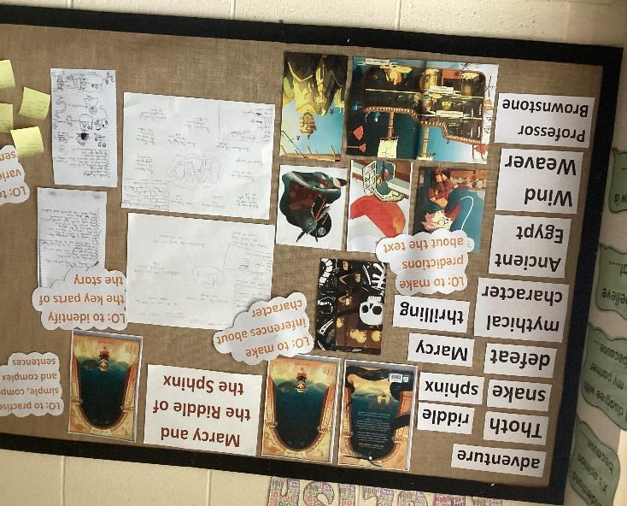

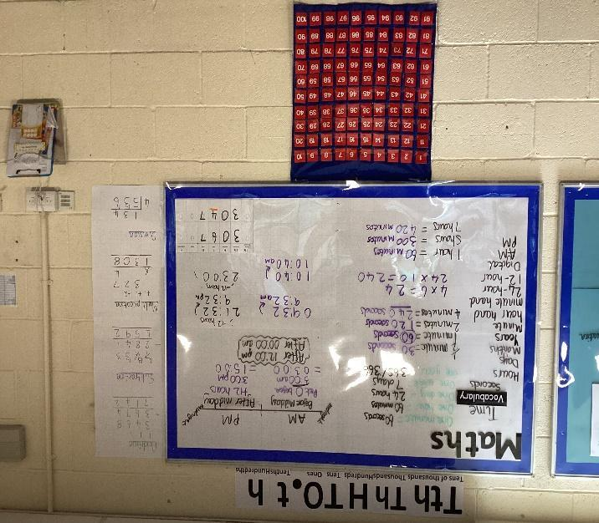
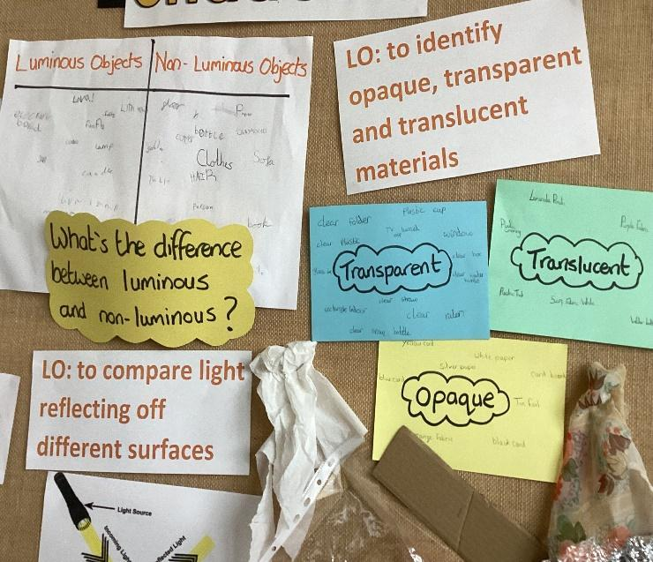

Reading Corners
‘The best classroom book areas are like mini bookshops. The challenge is to offer pupils choice, without overwhelming them’
- Organise books into 3 boxes ready for each term each year. These should be labelled Autumn, Spring and Summer.
- Books organised into these should consider topics that will be taught and relevant books to these.
- Organise books into categories eg: Adventure stories, animals stories, picture books, non-fiction books, poetry, books linked to our topics, recommended books.
- Place a small number of books in baskets for a category. These must be outward facing.
- Label the categories.
- Stand books on shelves outward facing.
- Space books out so children are not overwhelmed by choice.
- Rotate book stock each term.
- Refresh book stock within a term by putting books linked to topics out when a new topic is introduced. (it can be moved to appropriate categories after topic)
- Keep our reading areas low stimulus and simple.
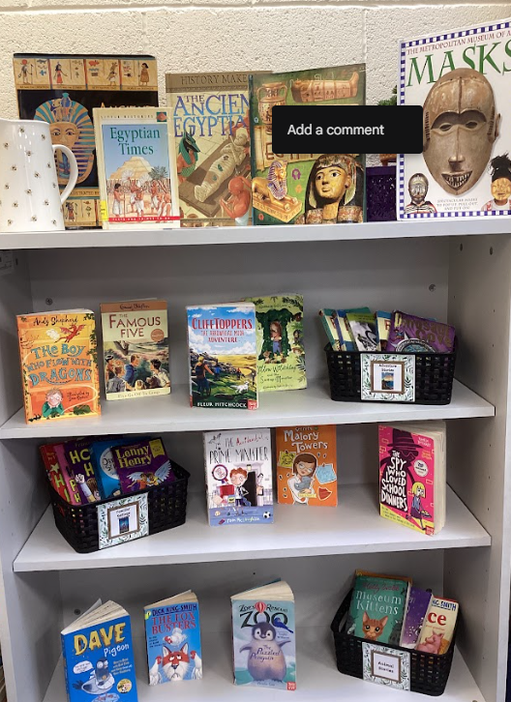
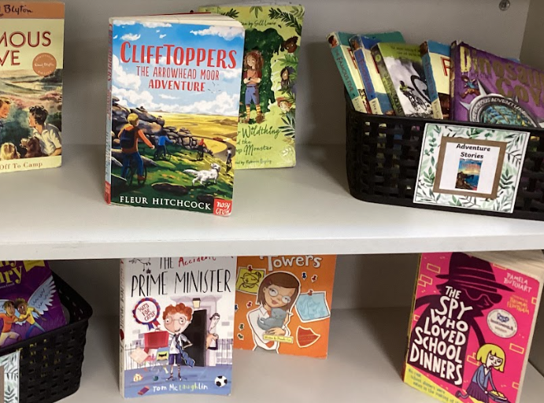
‘Every book must be worth reading or help pupils to put in the reading miles. Books that are unlikely to achieve either of these aims should be discarded.

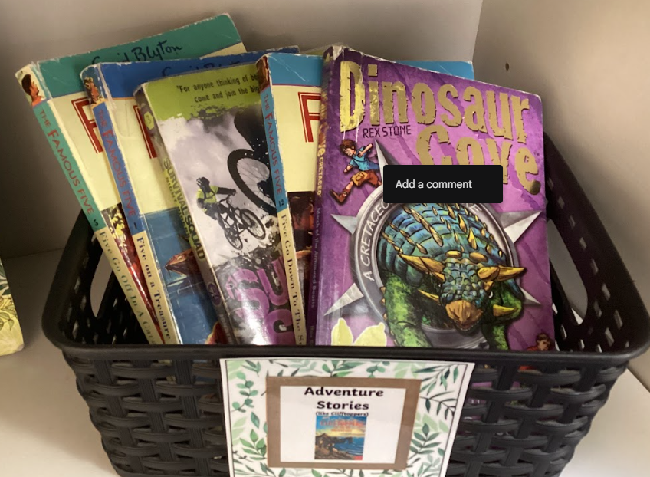

EYFS Classroom Environment
Our EYFS classroom at Blakehill is a stimulating, safe, and engaging environment that supports children's holistic development. It is well-organized and labelled with clearly defined areas for different types of play and learning, such as creative, construction, role-play, and reading corner. The space is flexible which allows for both independent and group activities, and also promotes both indoor and outdoor learning opportunities. Our EYFS environment is not only functional but also fosters a positive and enriching learning experience for all children.
Designated Learning Areas:
- Continuous Provision: Clearly defined areas for activities like maths, phonics, and literacy with appropriate resources.
- Creative Area: A space for painting, drawing, crafting, and other creative activities.
- Role Play Area: A space for imaginative play, often including a home corner, dress-up clothes, and props.
- Construction Area: Space for building with blocks, construction toys, and other materials.
- Reading Corner: A calm and comfortable area for quiet reading and relaxation.
- Sensory Area: A space to explore textures, smells, and other sensory experiences - mirror box and light box.
- Outdoor Area: Access to an outdoor space for physical activity, exploration, and learning.
- Fine Motor Skills Area: A "finger gym" with activities to develop fine motor skills.
- Small World Area: A space for playing with miniature figures and objects
- Other areas including: Mark making, water and sand, playdough and music
Key Features and Considerations:
- Safety: Prioritizing a safe environment for all children is crucial.
- Flexibility: The space is adaptable to different activities and group sizes.
- Accessibility: All areas are easily accessible and well-organized.
- Stimulating Environment: The classroom is visually appealing and encourages exploration.
- Independent Learning: Encouraging children to choose activities and explore independently.
- Adult Support: Providing opportunities for both adult-led and child-initiated learning.
- Observation and Assessment: The environment should facilitate observation and assessment of children's progress.
- Visual Aids: Using visual timetables, labels, and displays to support learning.
- Emotional Wellbeing: Creating a calming space for children to regulate their emotions (zones of regulation).
- Resources: Having a wide range of appropriate and engaging resources.

Inclusivity:
- SEND Considerations: The environment is accessible to children with special educational needs.
- Cultural Sensitivity: Our classroom reflects the diverse backgrounds of the children.
- Individual Needs: Our classrooms cater to the individual needs and interests of each child
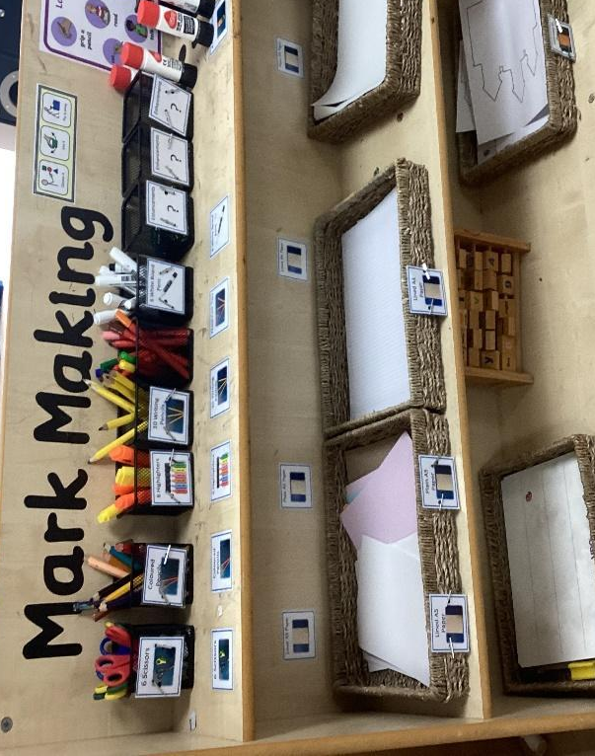
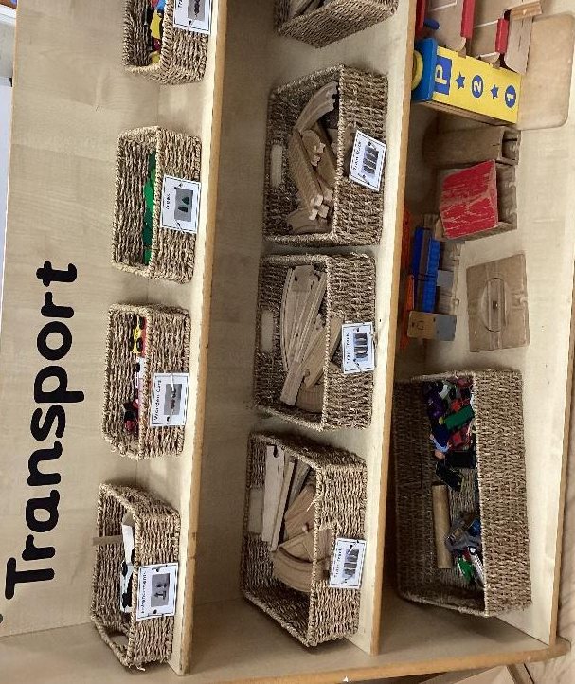

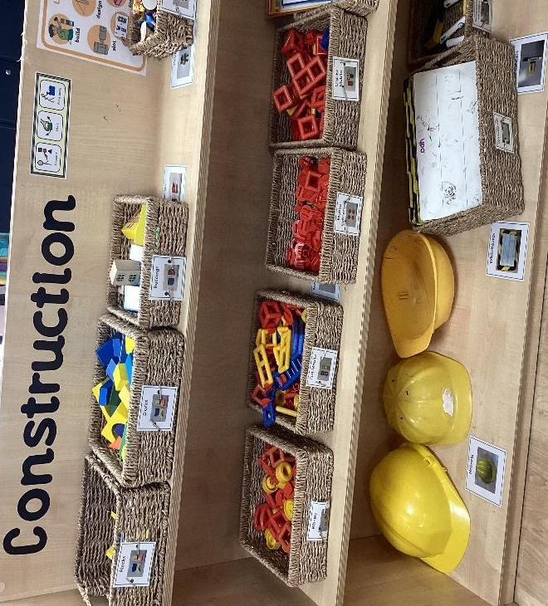
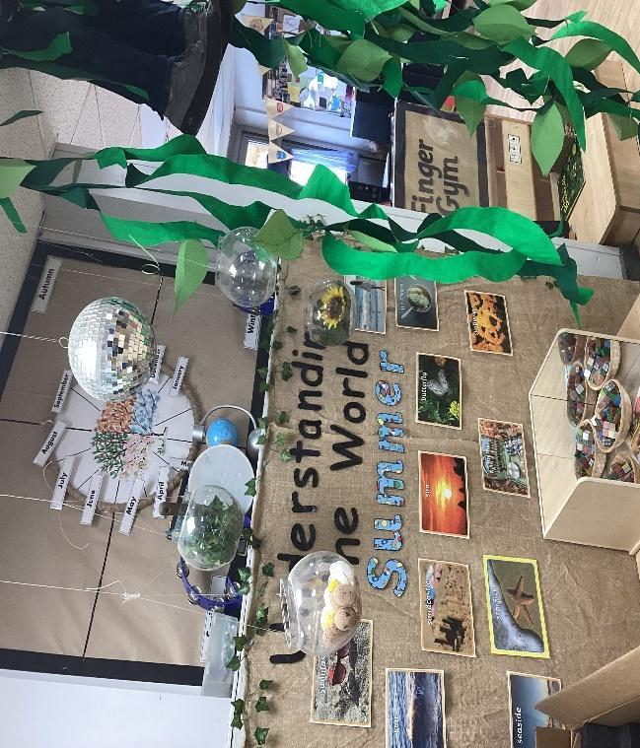

Classroom Environment Checklist for Year 1 - 6
Classroom Door
Photo of staff
Photo of Class councillor
Classroom
School Rules
Talk rules and talk structures
Zones of regulation poster
Phonics Poster
Labelled medical bag location
Worry Box
Raffle Ticket Box
Paper Register on show
Number of children present on template
Visual timetable
Work wall for English, Maths and Topic
Celebration of pupil’s work
Boxes of pupil books and trays clearly labelled
Writing equipment/resources available on tables
Tops of cupboards and surfaces clutter free
Groupings of tables meet the needs of the pupils
Home tray next to the door
Low in stimulus and colour
English Working Wall
Vocabulary on the left
Text title and photocopy of the text cover
Key objectives with modelled work/examples
Maths Working Wall
Title of current unit of work
Vocabulary on the left
Evidence of work and key facts
Four calculations as stated above
Number tracks as stated above if applicable
Hundred square near working wall
Place Value cards above working wall
Maths equipment labelled and accessible
Working wall backed in square paper
Topic Working Wall
Clear subject and title of unit of work
Vocabulary on the left
Key facts and work as you move through the unit
Working Walls
Text is a good size for pupils to see
Uncluttered and plain in colour and design
Working walls are showcasing current learning

