To Know the decimal and percentage equivalents of the fractions ¼, ½, ¾, ⅓, ⅔, tenths and fifths.
By the end of this half term, children should know the following facts. The aim is for them to recall these facts instantly.
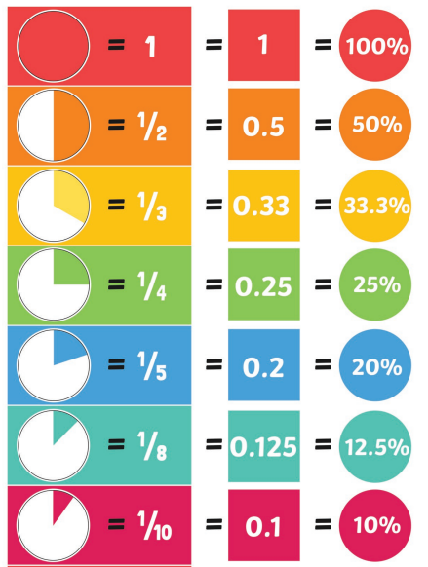 | Key Vocabulary  Write 0.75 as a fraction.  Write ¼ as a decimal.  What is ¾ as a percentage?
Children should be able to convert between decimals, fractions and percentages for ½, ¼, ¾ and any number of tenths and fifths.

Top Tips
The secret to success is practising little and often. Use time wisely. Can you practise these KIRFs while walking to school or during a car journey? You do not need to practise them all at once; perhaps you could have a fact of the day.
Play games – Make some cards with equivalent fractions, decimals and percentages. Use these to play the memory game or snap. Or make your own dominoes with fractions on one side and decimals on the other.

