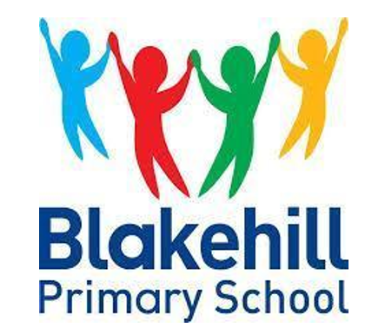
Spoken Language Curriculum
‘Talk is the sea upon which all else floats’ – James Britton 1970

Oracy is the deliberate teaching of speaking and listening skills. It is a foundational life skill, a gateway into literacy and the central focus in modern education. At Blakehill, we teach pupils ‘to talk’ while also teaching the pupils ‘through talk’. Oracy is central to our whole curriculum and benefits the pupils in many ways.
Cognitive Growth and Literacy Development: Spoken language forms the bedrock for reading and comprehension - a life skill pupils continue to develop throughout their life. When children talk about concepts first, they are much more able to apply this to writing. Oral discussions also deepen meaning and critical thinking which every good learning experience needs.
Emotional Regulation and Social Skills: Verbal fluency reduces behavioural frustration in children if they have the ability to express their feelings. Often this extends into the playground, where pupils are enabled to solve playground disputes peacefully and without adult support. This also feeds into our ‘Behaviour Policy’. Structured listening experiences help children understand peer perspectives – a vital skill for later life also.
Inclusion: Early Oracy and teaching spoken language objectives, as soon as pupils arrive at school, levels out the playing field for disadvantaged pupils. Building confidence, through oral opportunities, gives every child a voice and reduces social anxiety. Oral activities throughout the day, support SEND pupils with retrieving key vocabulary and information as well the extra support to express their views and ideas on paper.

Learning engagement: Pupils who are able to explain their thinking, helps the pupil understand how they learn (metacognition). Collaborative, reciprocal and collective talk discussions, as well as quick ongoing oral recall activities, result in high engagement in lessons. This practice supports the pupil’s retention of key concepts and ideas, as they have been explored out loud.

Spoken Language in Early Years
At Blakehill, Oracy begins in Reception. Speaking and listening skills are explicitly taught and modelled by practitioners throughout the school day. Practitioners in the early years, enhance practice through, ‘Sustained Shared Thinking’ whilst supporting children in their independent learning. All early years practitioners have a secure understanding of the ShREC approach and use this to further support and develop children's understanding and their spoken language skills. ‘The development of children's spoken language underpins all seven areas of learning and development. Children's back and forth interactions from an early age form the foundations for language and cognitive development’ - Development Matters.

Spoken Language Years 1 - Year 6

As pupils progress through school, we teach the National Curriculum Spoken Language objectives using the Voice 21 Oracy framework. This framework has split the NC objectives into four key strands of Oracy: Physical, Linguistic, Cognitive and Social and Emotional. These strands help us scaffold the learning for the pupils, focusing on a key objective linked to each of the strands, each half term. We have used this framework to develop our own Oracy curriculum, using child speak objectives and 3 key milestones for the pupils. This means that pupils, over a two year period, have opportunities to revisit each objective; this then helps embed these skills, before moving on. Oracy opportunities and time to explore these objectives are planned for and included in our Blakehill four-part lesson structure. These objectives are a key focus in all our learning and are visually prioritised in our classroom environment, for all to see.
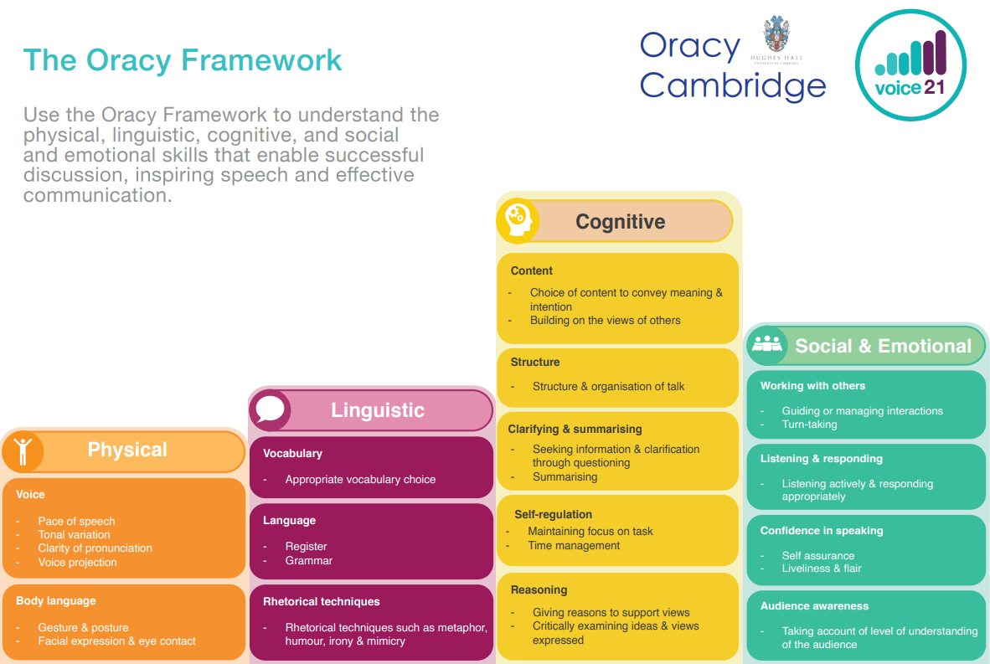
Blakehill Oracy Curriculum

Term | Milestone 1 (KS1)  Talk Rules | Milestone 2 (LKS2)  Talk Rules | Milestone 3 (UKS2)  Talk Rules
Autumn 1 | Physical  I can look at the person who is speaking.  Linguistic  I can choose the right word when someone is describing something.  Cognitive  I can ask a question to help me understand.  Social and Emotional  I can listen to a question and give a suitable answer. | Physical  I can use eye contact and move my body so the speaker knows I am listening.  Linguistic  I can use the correct grammar when speaking so I am making sense to my listener.  Cognitive  I can stay on topic when discussing something specific.  Social and Emotional  I can respond in any discussion so my audience knows I am listening. | Physical  I can use a variety of body language to support my discussions.  Linguistic  I can use vocabulary appropriate to formal and informal situations.  Cognitive  I can listen to the opinions of others and compare different points of view.  Social and Emotional  I can listen actively and respond appropriately regardless of my audience.
Autumn 2 | Physical  I can turn my body so the person speaking knows I am listening.  Linguistic  I can talk about words that look or sound the same.  Cognitive  I can tell someone that I don’t understand something and explain why.  Social and Emotional  I can perform in front of an audience. | Physical  I can speak clearly and pronounce all the sounds in my words.  Linguistic  I know when someone is joking or using humor in their interactions.  Cognitive  I can ask and answer questions appropriately inside and outside of the classroom.  Social and Emotional  I can invite others to share their opinions so they feel included. | Physical  I can speak clearly and project my voice appropriately for my audience.  Linguistic  I can use rhetorical techniques e.g. irony, metaphors, mimicry and humour.  Cognitive  I can ask specific questions to help me work out the part I don’t understand or want more information about.  Social and Emotional  I can identify when I have shared enough and will invite others to join in.
Spring 1 | Physical  I can use facial expressions to encourage the person who is speaking.  Linguistic  I know I speak differently with my friends and a visitor to school.  Cognitive  I can give my opinion to my friend and class.  Social and Emotional  I can take my turn speaking with my partner. | Physical  I can speak at the right pace to keep my listener’s attention.  Linguistic  I can add extra detail and specific words to help my listener understand more.  Cognitive  I can build or add information onto the views of others to show I am listening.  Social and Emotional  I can take turns when speaking and make sure I am not sharing too much. | Physical  I can use the tone of my voice to engage and interest my audience.  Linguistic  I can use varied and ambitious vocabulary to make my sentences more complex.  Cognitive  I can explain, negotiate and predict certain outcomes.  Social and Emotional  I can assist another speaker if they are seeking support.
Spring 2 | Physical  I can pronounce my words clearly.  Linguistic  I know when someone is joking.  Cognitive  I can listen to my friend and add on more information.  Social and Emotional  I can take my turn speaking in a small group. | Physical  I can project my voice according to my audience e.g. my friend or a hall of people.  Linguistic  I can use words to describe various feelings and find out how my friends feel about the same thing.  Cognitive  I can agree/disagree with my friends in a respectful way and explain why.  Social and Emotional  I can use expression to engage my listener. | Physical  I can use posture and gesture to support my communication.  Linguistic  I can use specific topic words accurately when explaining about my learning.  Cognitive  I can share my opinions with others, then listen, build or challenge again, over a longer period of time.  Social and Emotional  I can speak with liveliness and flair to engage my audience.
Summer 1 | Physical  I can speak loud enough for my whole class to hear.  Linguistic  I can use lots of interesting words in my sentences.  Cognitive  I can stay focused on the topic we are discussing.  Social and Emotional  I can make my voice sound interesting for the listener. | Physical  I can change the tone of my voice for any reason e.g. adding surprise.  Linguistic  I know I speak differently when speaking with different people e.g. friend and school visitor  Cognitive  I can summarise my views and the views of others in my class.  Social and Emotional  I can think about and alter my word choice depending on who I am talking to. | Physical  I can perform in front of a large audience with expression and confidence.  Linguistic  I consistently use the correct grammar when speaking so I am making sense to my listener.  Cognitive  I can debate a pre-planned topic with an opposition.  Social and Emotional  I can work collaboratively with a group to come to an agreed outcome.
Summer 2 | Physical  I can project my voice for all to hear in hall.  Linguistic  I can use topic words when talking about something factual.  Cognitive  I can disagree with my friend and give a reason why.  Social and Emotional  I can listen to instructions where I have to do several different things. | Physical  I can use my body posture and added expression when performing in front of a larger audience.  Linguistic  I can show I understand specific words when talking about my current learning topics.  Cognitive  I can critically and respectfully examine the views of others by asking clarifying questions.  Social and Emotional  I can work well with others and show my understanding that everyone shares different viewpoints. | Physical  I can perform in front of a large audience with expression and confidence.  Linguistic  I can adapt my word choice according to my audience and the purpose behind the communication.  Cognitive  I can summarise what other people suggest or think and make my own suitable suggestion based on this.  Social and Emotional  I can work collaboratively with a larger group to reach an agreed outcome.

