Year 5
Our Yorkshire
Investigating land use and human settlement
Links made with other subjects | Residential: Ingleborough  Art: Drawing  English: Comparative reports
The BIG Question | Are Idle and Clapham similar locations?
The BIG Outcome | Children to create a comparative report (linked to English unit) demonstrating the knowledge and skills they have learnt; identifying the similarities and differences between:  - Physical (elevation, urban vs rural, vegetation, key physical landmarks e.g. rivers)  - Human (land use, population, resources)  Children could apply English skills in addition to: Speaking and Listening: Present to class / parents / video.
Geography objectives  (link to NC) | - Name and locate counties and cities of the UK, geographical regions and their identifying human and physical characteristics, key topographical features and land use patterns and understand how some of these aspects have changed over time.  - Describe and understand key aspects of physical geography including vegetation belts, rivers and the water cycle.  - Describe and understand key aspects of human geography including types of settlement and land use, economic activity including trade links and the distribution of natural resources including energy, food and minerals.  - Use maps, atlases, globes and digital/computer mapping and describe features studied.  - Use the eight points of a compass, four and six figure grid reference, symbols and keys to build their knowledge of the UK.  - Use fieldwork to observe, measure, record and present the human and physical features in the local area.
Prior knowledge  What prior knowledge is needed for children to be successful in this unit? | Children already know:  - Y1 – Who are we and where are we? (UK Knowledge)  - Y1 – Town Mouse, Country Mouse (and seaside mouse too!) (Comparison between city, town and coast)  - Y2 – Where would you rather be? (Comparison between Bradford and Nairobi)  - Y3 – Oh I do like to be besides the seaside (Coastlines)  - Topographical features of a coastline.  - Made comparisons to a different locality  - Understand the impact of changes to the environment on people.  - Y4 – The Journey to the Sea (Rivers)  - Topographical features of a river.  - Explored the change from higher ground to lower ground.  - Made comparisons to a different locality and understand the impact of topographical features on where people chose to settle.  - Y4 – Why settle here? (Natural resources & settlements)  - Understand physical characteristics determine where people settle then and now.  - Know that land use has changed over time.  - Know that historically rivers, natural resources e.g. woodland and a high vantage point made a good settlement.  - Know that priorities for settlement have now change but they are still based around the availability of resources.
Future learning  Consider the conceptual knowledge within a subject that pupils need for future learning not just the recall of facts but the importance of concepts | This unit gives prior knowledge to:  - Y6 – Rainforests. Topographical features, human land use.
Geographical strands | Geographical Skills  - Use topographical maps to identify the features of the land.  - Use keys, OS maps and atlases to identify the features of the landscape.  - Use maps to navigate.  - Use sketches to show an area.  - Use symbols and a key to add detail to my sketch.  Locational Knowledge  - Use the 8 points of a compass to describe the locations.  - Locate the counties of the UK  - To locate Clapham on a map.  - To locate Idle within Bradford.  Place Knowledge  - To know the topography of Idle.  - To know the topography of Clapham.  - To know the different types of land use in Idle.  - To know the different types of land use in Clapham.  Environmental, human and physical geography  - To make comparisons between two localities.  - To identify trade links between Bradford, Clapham and beyond.
Vocabulary/ Glossary | counties, topography, contour lines, elevation, valley, hill, mountain, land use, residential, agricultural, recreation, transportation, and commercial, navigate, north, north east, east, south east, south, south west, west, north west.
Knowledge  (see italics for knowledge to remember) | The knowledge that children will learn and remember:  - A county is an administrative or ceremonial region with clearly defined geographical boundaries. The formation of English counties can be traced back to the Norman Conquest. A County was an area that was overseen by a Count. Counties replaced the Saxon Shires. An old name for Shire is a Sheriffdom. Looked after by an official called a Shire-Reeve later known as a Sherriff. Some counties in England have never been Shires. This is because they were either Kingdoms in their own right, (Sussex, Essex, Kent) or because they resisted Saxon invasion following the withdrawal of the Roman legions in 400 AD, (Cornwall, Devon and the whole of Wales).  - There are 48 counties in England. Children will locate all of these on the map but recall our local counties:  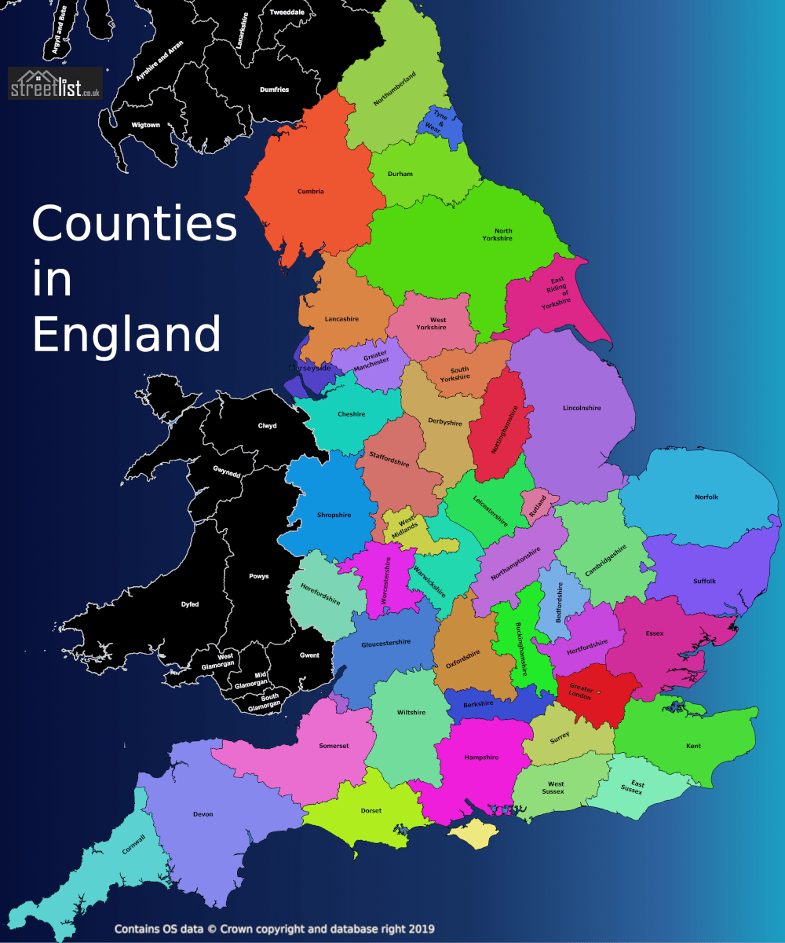  Yorkshire  Lancashire  Cheshire  Derby  Nottinghamshire  Lincolnshire  Cumbria  Durham  - Topography map:  - A topography map shows us what the land looks like.  - Contour lines on a topographical map show elevation.  - Click terrain on google maps.  - The lines (contour lines) on a topography map show where the land gets higher (elevation).  - When the lines are close together it shows you it is a steep area.  - The green shows forest/ areas of pasture (grass).  - Blue shows rivers, big streams or bodies of water.  - Black lines show roads/ trainlines.  - Topography of Clapham:  - North Yorkshire  - Village is based at the bottom of Ingleborough mountain  - Village in a valley.  - 200m elevation.  - In the Yorkshire Dales.  - Clapham Beck (beck = stream) Draw links to Y4 Rivers topic: high elevation = upper course of a river = stream, waterfalls, fast flowing.  - Behind the village is Ingleborough mountain an area of high elevation.  - Gaping Gill – England’s highest waterfall.  - Ingleborough Cave  - It is a rural area (lots of green shown on the map)  - It has one train station.  - Topography of Idle:  - West Yorkshire  - Village based near the top of a hill.  - 200m elevation.  - By the City of Bradford.  - River Aire runs in the valley below. Draw links to Y4 Rivers topic: lower elevation = middle course of a river = wider, a river, slower flowing.  - Idle Moor  - 5 Lane Ends Retail Park  - It is an urban area (lots of grey shown on the map)  - It has four train stations in the local area.  - There are 5 types of land use: residential, agricultural, recreation, transportation, and commercial. Children will identify different buildings on a map (a road map/ OS is best here) to find examples of these in each area.  - Comparisons between Clapham and Idle:  - Both 200m elevation but Clapham in a valley, Idle near the top of a hill.  - Both have bodies of water near them but Clapham = tributary (stream) because higher elevation; Idle = river because of lower elevation.  - Urban area vs rural area demonstrated with difference in land use: agricultural vs residential. Commercial.  - Trade links:  - Glencroft – Clapham business selling wool products, sheepskin etc. Established in Clapham. Now has it’s head office in Bradford where it collects and sorts the wool for its jumpers and products.  - Discuss / children consider why head office is in Bradford not Clapham.  - Bradford = resources (staffing, factories etc)  = easy road links – motorways so accessible.  - Clapham = remote and hard to get to.
SEND expectations | - A county is an administrative or ceremonial region with clearly defined geographical boundaries.  - We live in Yorkshire.  - Clapham:  - North Yorkshire  - Village is based at the bottom of Ingleborough mountain  - Village in a valley.  - In the Yorkshire Dales.  - Idle:  - West Yorkshire  - Village based near the top of a hill.  - By the City of Bradford.  - There are 5 types of land use:  residential, agricultural, recreation, transportation, and commercial  - Comparisons between Clapham and Idle:  Clapham = rural  Idle = urban
Teaching ideas/ resources | - https://www.glencroftcountrywear.co.uk/manufacturing/the-origins-of-british-wool/  - https://www.glencroftcountrywear.co.uk/who-we-are/2506/
Suggested Teaching Sequence | Session One  Points 1 and 2. Children will know what a county is, that England has 48 and will find them on a map.  Session Two  Points 3, 4 and 5. Children will know what topography is and will have found topographical features of Idle and Clapham.  Session Three  Points 6. Children will know what land use is and what the different types are.  Session Four  Point 7. Children will use their knowledge of topography and land use to make comparisons between Clapham and Idle.  Session Five  Point 8. Children will know how Bradford and Clapham’s trade links differ. (pose the scenario that Glencroft’s head office are thinking of relocating to Clapham. Is this a good idea? Why?)  Session Six: Assessment

