**Art Vocabulary**

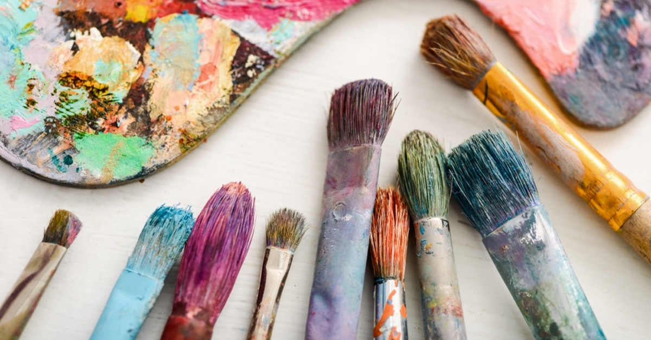

Pencil line thickness thick thin charcoal chalk pastel oil pastel sharp blunt length long short broad narrow straight curved Mondrian artist

**Art Vocabulary**



Paint primary colour secondary colour mix shade light dark tint tone thick thin

Mondrian

**Art Vocabulary**



Materials collage textiles product squeeze pinch plasticine clay tiles texture pattern cut roll coil join print repeating pattern press rue stamp Antony Goldsworthy sculpture natural form