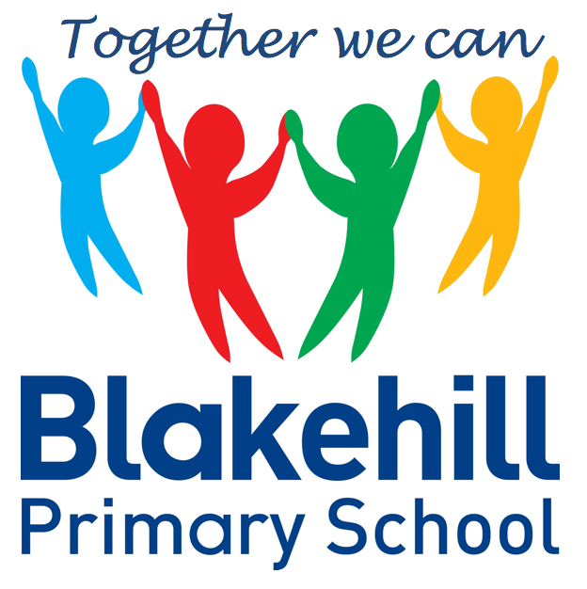
English
- Stories with Familiar Settings
- Labels, captions and lists.
- Write sentences using secure phonic knowledge
- To use finger spaces between words.

You can help your child by talking about settings, characters and events in stories that you read.
Try to read/share a book daily whenever possible.

Please also help your child learn any reading words or spellings sent home.

Science - Ourselves
- Identify and name parts of the body.
- Find out how we use the 5 senses.
- Carry out a simple investigation.

Geography – Map skills
- Follow a simple map.
- Find locations on a map.
- Find evidence of Jowett cars in Idle.

History – Changes within living memory
- Find out who the Jowett brothers were and why they were important in Idle.

Art – Drawing Skills
- Self-portraits.
- Observational drawings.
Design and Technology – Mechanisms
- Design, make and evaluate a moving picture

Science, History, Geography, Art and D&T
- PSHCE & RE– Ourselves – What makes me special?
Outdoor – Striking and Fielding – Develop hitting and kicking skills.
Indoor – Games skills – Catching and throwing with a partner.

To begin to use the ICT suite to learn how to log on and off the chrome books independently.

E-Safety - Discuss rules for keeping safe on the internet.

- Reading: Practise high frequency words – children need to know these words by sight without needing to sound them out. Children will receive a high frequency card with additional information on.
- Spellings: Practise any word mountain spellings sent home. Children will be tested on a Friday.
- PE: Year 1 will have PE on Tuesdays and Thursdays.

Please ensure every day that your child has a water bottle filled with water only please.

Homework and other information
Exploring sounds through the Charanga Music Scheme
Topic: Ourselves
Half Term Curriculum Overview

- Place value ( within 10 )
- Addition and Subtraction ( within 10 )
- Form numbers correctly
- Count in 10s, 2s and 5s
- Know pairs of numbers that make 5
- Know pairs of numbers that make 10

Mathematics
PSHCE and RE
Physical Education
Computing
Music
Year 1 Autumn 1 2021
Ourselves

