To recite the number names in order to 100.
To know all number bonds for 10 and 20.
By the end of this half term, children should know the following facts. The aim is for them to recall these facts instantly.
Children should be able to count confidently and quickly to 100 and be able to count on from any number.  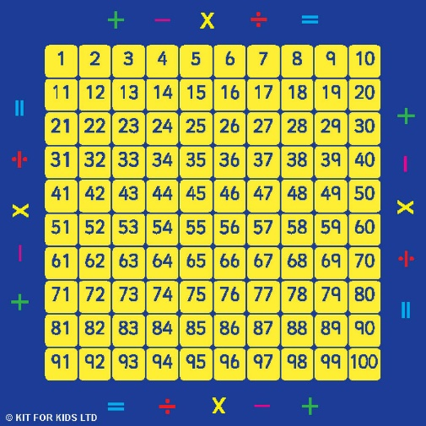 | Children should know all the number bonds to 10:  0 and 10  1 and 9  2 and 8  3 and 7  4 and 6  5 and 5  (and the other way round) The children should also know them as a number sentence:  0 + 10 = 10  1 + 9 = 10  2 + 8 = 10  3 + 7 = 10 etc. | Children should know all the number bonds to 20:  0 and 20  1 and 19  2 and 18  3 and 17  4 and 16  5 and 15  6 and 14  7 and 13  8 and 12  9 and 11  10 and 10  (and the other way round) Again the children should also know them as a number sentence e.g. 0 + 20 = 20

Top Tips
The secret to success is practising little and often. Use time wisely. Can you practise these KIRFs while walking to school or during a car journey? You don’t need to practise them all at once: perhaps you could have a fact of the day.
Pronunciation – Make sure that your child is pronouncing the numbers correctly and not getting confused between thirteen and thirty.
Songs and Chants – You can buy CDs or find number bond songs and chants online. If your child creates their own song, this can make them even more memorable.
Playing games can make learning number bonds fun and exciting: http://www.conkermaths.org/cmweb.nsf/products/conkerkirfs.html
See how many questions you can answer in 90seconds.
https://www.topmarks.co.uk/maths-games/daily10 and https://www.topmarks.co.uk/maths-games/hit-thebutton

