**Art Vocabulary**

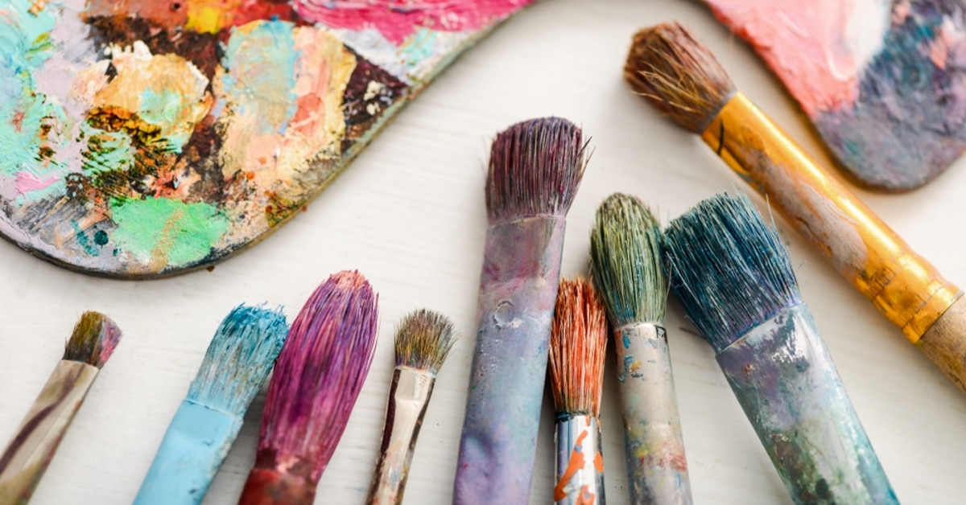

perspective line movement

**Art Vocabulary**



watercolour acrylic colour layering movement tones tints texture Banksy

**Art Vocabulary**



compare styles experiment research montage abstract combine wire plaster   
mod-rock Picasso