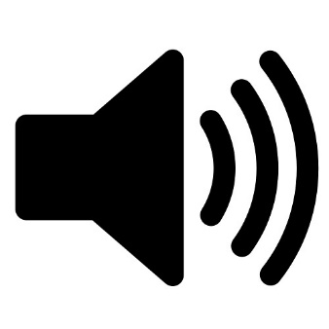

**Y4: Sound (sound)**

Sound, source, vibrate, vibration, travel, pitch (high, low), volume, faint, loud, insulation

**Science Vocabulary**

**Sound**



Any other words: