
CLASS
6N
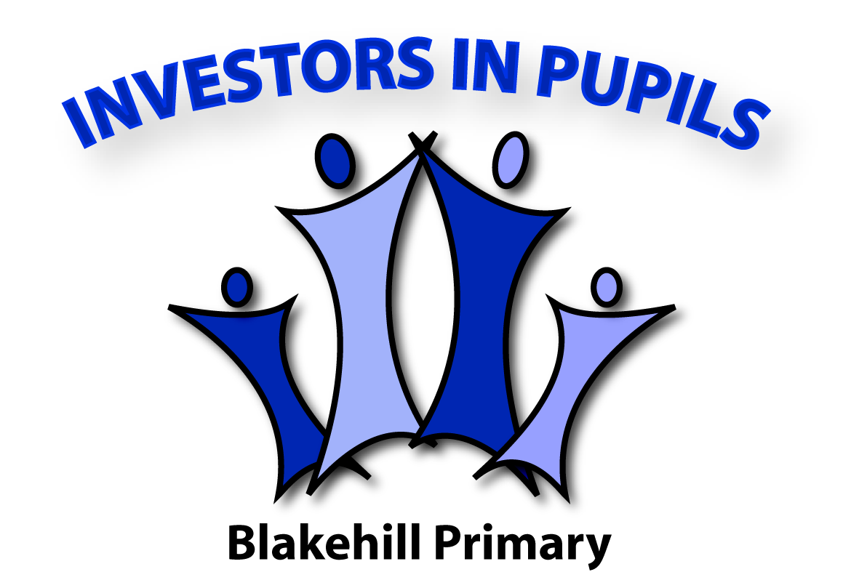
Our Mission Statement
We will always stay focused and give 100% effort so that we can do our best learning.

We never give up and if we get something wrong, we will try, try and try again.

We learn from our mistakes. Mistakes help the teacher (and our classmates) to support us and get better at things we struggle with.

We love to share our ideas and will always acknowledge and support each other.

We are very respectful towards everything and everyone around us. We will show that we care for our classmates.

Signed:

