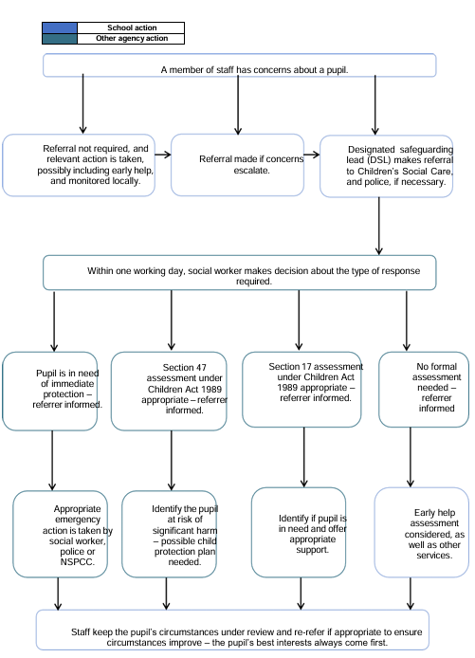**Concerns about a pupil flowchart**