To recognise decimal equivalents of the fractions
¼, ½, ¾, tenths and hundredths.
By the end of this half term, children should know the following facts. The aim is for them to recall these facts fairly instantly.
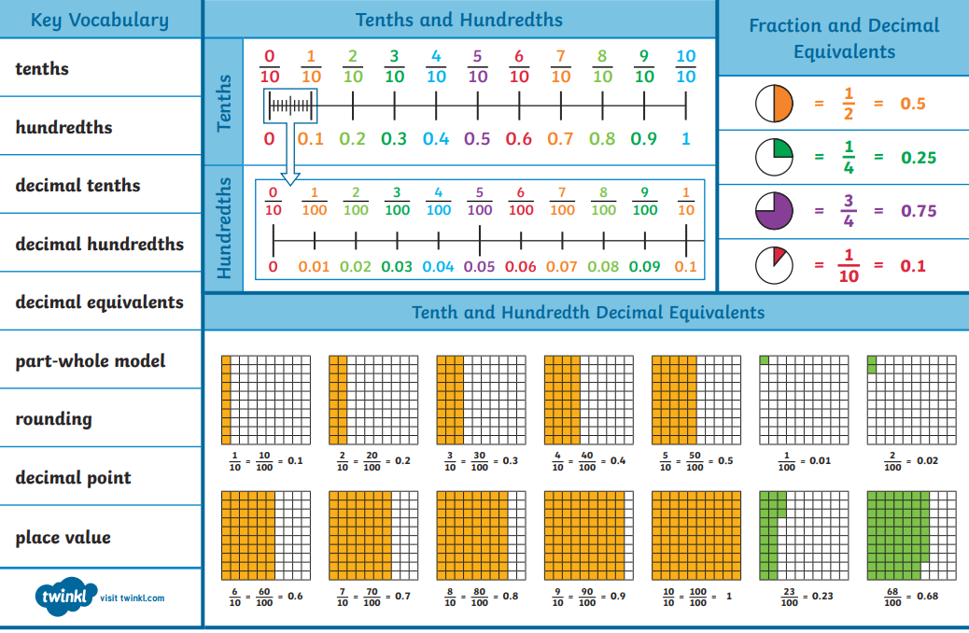

Top Tips
The secret to success is practising little and often. Use time wisely. Can you practise these KIRFs while walking to school or during a car journey? You don’t need to practise them all at once: perhaps you could have a fact of the day. Buy one get three free – If your child knows one fact (e.g. 9 x 12 = 108), can they tell you the other three facts in the same fact family?
Use memory tricks – For those hard-to-remember facts, create picture stories to help children remember.

